3.1.2 - 3D View by tools - Header
Detailed Table of content 1
Introduction 16
Header 16
All Modes - View Menu 16
All Modes - Navigation Menu 24
All Modes, all Object types - Show / Hide 29
Object Mode - Select menu 30
Object Mode - Object menu 38
Edit Mode - Mesh Object - Mesh Menu 48
Edit Mode - Curve + Surface Object - Curve + Surface Menu 58
Edit Mode - Metaball Object - Metaball Menu 60
Edit Mode - Text Object - Text Menu 62
Edit Mode - Armature Object - Armature Menu 63
Edit Mode - Lattice Object - Lattice Menu 70
Pose Mode - Armature Object - Pose Menu 70
Sculpt Mode - Sculpt Menu 80
Sculpt Mode - Brush Menu 80
Sculpt Mode - Hide/Mask Menu 80
Vertex paint Mode - Paint Menu 82
Weight Paint Mode - Select Menu 84
Weight Paint Mode - Weights Menu 87
Texture Paint Mode - Select Menu 87
Particle Mode - Select Menu 90
Particle Mode - Particle Menu 92
Grease Pencil - Edit Strokes Mode 93
Header Tool - Mode Drop-down Box 100
Header Tool - 3D Manipulator Widget 101
Header Tool - Proportional Editing 102
Header Tool - Transform Snapping 103
Header Tool - Viewport Shading 104
Header Tool - Pivot Point 105
Header Tool - Manipulate Center Points 105
Header Tool - Mesh Object - Edit Mode - Mesh Select Mode 106
Header Tool - Mesh Object - Edit Mode - Limit Selection to Visible 106
Header Tool - Mesh Object - Face selection masking for Painting 107
Header Tool - Mesh Object - Vertex selection masking for Painting 107
Header Tool - Particle Edit - Select modes 108
Header Tool - Reset 3D View 108
Header Tool - Align View Buttons 109

Detailed Table of content

3.1.2 - 3D View by tools - Header detailed
Detailed Table of content 1
Introduction 16
Header 16
All Modes - View Menu 16
Toggle Full screen Area 17
Toggle Maximize Area 17
Toggle Quad view 18
Duplicate Area into New Window 18
View All 18
Center Cursor and View All 18
View All all Regions 18
View Selected 19
View Selected All Regions 19
View Global / Local 19
Render Border 19
Clear Render Border 20
Clipping 20
Clear All Restrict Render 20
Restrict Render Unselected 21
Set Restrict Render 21
Align View to Active 21
Align View 21
Align Active Camera to View 21
Align Active Camera to Selected 21
Center View to Cursor 22
View Lock to Active 22
View Lock Center 22
View Lock Clear 22
View Persp/Ortho 22
Top, Bottom, etc. 22
View Camera Center 22
Active Camera 23
Set Active Object as Camera 23
OpenGL Render Animation 23
OpenGL Render Image 23
Tool Shelf 24
Properties 24
All Modes - Navigation Menu 24
Scale 25
Last Operator Resize 25
Vector 25
Constraint Axis 25
Orientation 25
Proportional Editing 25
Proportional Editing Falloff 25
Proportional Size 25
Edit Grease Pencil 25
Edit Texture Space 25
Rotate 25
Last Operator Translate 25
Angle 25
Constraint Axis 26
Orientation 26
Proportional Editing 26
Proportional Editing Falloff 26
Proportional Size 26
Edit Grease Pencil 26
Translate 26
Last Operator Translate 26
Vector 26
Constraint Axis 26
Orientation 26
Proportional Editing 26
Proportional Editing Falloff 27
Proportional Size 27
Edit Grease Pencil 27
Edit Texture Space 27
Playback Animation 27
View Navigation 27
Walk Navigation 27
Fly Navigation 27
Center View to Mouse 27
Dolly View 27
Zoom Camera 1:1 28
Zoom In 28
Zoom Out 28
Zoom Border 28
Pan Left 28
Pan Right 28
Pan Up 28
Pan Down 28
Roll Right 29
Roll Left 29
Orbit Opposite 29
Orbit Left 29
Orbit Right 29
Orbit Up 29
Orbit Down 29
All Modes, all Object types - Show / Hide 29
Show Hidden 29
Hide Selected 30
Hide Unselected 30
Last Operator Show Hidden 30
Object Mode - Select menu 30
Less 30
More 30
Child Extended 31
Parent extended 31
Child 31
Parent 31
Last Operator Select Hierarchy 31
Direction 31
Extended 31
All by Type 31
Last Operator Select By Type 32
Extend 32
Type 32
All by Layer 32
Last Operator Select by Layer 32
Match 32
Extend 32
Layer 32
By Pattern 32
Pattern 33
Case Sensitive 33
Extend 33
Last Operator Select Pattern 33
Pattern 33
Case Sensitive 33
Extend 33
Linked 33
Object Data 33
Material 33
Texture 33
Dupligroup 34
Particle System 34
Library 34
Library (Object Data) 34
Last Operator Select Linked 34
Extend 34
Type 34
Grouped 34
Last Operator Select Grouped 34
Extend 34
Type 34
Camera 35
Last Operator Select Camera 35
Extend 35
Mirror 35
Last Operator Select Mirror 35
Extend 35
Random 35
Last Operator Select Random 35
Percent 35
Random Seed 35
Action 35
Inverse 35
(De)Select All 35
Last Operator (De)Select All 35
Action 35
Invert 36
Deselect 36
Select 36
Toggle 36
Circle Select 36
Border Select 36
Lasso Select 37
Stroke Select 37
Object Mode - Object menu 38
Convert to 38
Curve from Mesh/Text 38
Mesh from Curve/Meta/Surf/Text 38
Last Operator Convert to 38
Show/Hide 38
Game 39
Subdivide 39
Last Operator Subdivision Set 39
Level 39
Relative 39
Quick Effects 39
Quick Fur 39
Quick Explode 39
Quick Smoke 40
Quick Fluid 40
Constraints 40
Add Constraints ( With Targets) 40
Last Operator Add Constraints (with Target) 41
Type 41
Copy Constraints to Selected Objects 41
Clear Object Constraints 41
Clear Track 41
Last Operator Clear track 42
Type 42
Clear Track - Keep Transformation 42
Last Operator Clear track 42
Type 42
Make Dupli Face 42
Delete 42
Last Operator Delete 42
Delete Globally 42
Delete Global 42
Last Operator Delete 43
Delete Globally 43
Duplicate Linked 43
Last Operator Duplicate Linked 44
Duplicate Objects 44
Linked 44
Translate 44
Constraint Axis 44
Orientation 44
Proportional Editing 44
Proportional Editing Falloff 44
Proportional Size 44
Edit Grease Pencil 44
Edit Texture Space 44
Duplicate Objects 44
Last Operator Duplicate 45
Duplicate Objects 45
Linked 45
Translate 45
Constraint Axis 45
Orientation 45
Proportional Editing 45
Proportional Editing Falloff 45
Proportional Size 45
Edit Grease Pencil 45
Edit Texture Space 45
Copy 46
Paste 46
Last Operator Paste Selection from Buffer 46
Select 46
Active Layer 46
Apply 46
Location, Rotation, Scale and Rotation&Scale 46
Last Operator Apply Object Transform. 46
Location 46
Rotation 46
Scale 46
Apply Properties 47
Location, Rotation, Scale and All Transforms to Deltas 47
Last Operator Transforms to Deltas 47
Mode 47
Reset Values 47
Animated Transform to Deltas 47
Clear 47
Location 47
Last Operator Clear Location 47
Clear Delta 47
Rotation 47
Last Operator Clear Rotation 48
Clear Delta 48
Scale 48
Last Operator Clear Scale 48
Clear Delta 48
Origin 48
Edit Mode - Mesh Object - Mesh Menu 48
Smart Delete 48
Show / Hide 49
Sort Elements 49
View Z Axis 49
View Y Axis 49
Cursor Distance 50
Material 50
Selected 50
Randomize 50
Reverse 50
Last Operator Sort Mesh Elements 50
Type 50
Vertices, Edges or Faces 50
Reverse Checkbox 51
Seed Edit box (Randomize only) 51
Noise 51
Last Operator Noise 51
Factor 51
Subdivide 51
Last Operator Subdivision Set 51
Level 51
Relative 51
Blend from Shape 52
Last Operator Blend from Shape 52
Drop-down box 52
Blend edit box 52
Add 52
Shape Propagate 52
Hooks 52
Hook to New Object 52
Hook to Selected Object 52
Last Operator Hook to Selected Object 53
Active Bone 53
Hook to Selected Object Bone 53
Assign to Hook 53
Remove Hook 53
Select Hook 53
Reset Hook 53
Recenter Hook 53
Vertex Groups 53
Assign to New Group 54
Assign to active Group 54
Remove from Active Group 54
Remove from All 54
Set Active Group 54
Remove Active Group 54
Remove All Groups 54
Mesh Select Mode 55
Last Operator Select Mode 55
Extend 55
Expand 55
Type 55
Action 55
Delete 55
Vertices 55
Edges 55
Faces 56
Only Edges and Faces 56
Only Faces 56
Last Operator Delete 56
Type 56
Edge Loops 56
Last Operator Delete Edge Loop 56
Face Split 56
Duplicate 56
Last Operator Duplicate 57
Duplicate Objects 57
Linked 57
Translate 57
Constraint Axis 57
Orientation 57
Proportional Editing 57
Proportional Editing Falloff 57
Proportional Size 57
Edit Grease Pencil 57
Edit Texture Space 57
Transform 57
Edit Mode - Curve + Surface Object - Curve + Surface Menu 58
Show/Hide 58
Hooks 58
Hook to New Object 58
Hook to Selected Object 58
Last Operator Hook to Selected Object 58
Active Bone 58
Hook to Selected Object Bone 59
Assign to Hook 59
Remove Hook 59
Select Hook 59
Reset Hook 59
Recenter Hook 59
Delete 59
Last Operator Delete 59
Type 59
Duplicate 59
Last Operator Duplicate 60
Duplicate Objects 60
Linked 60
Translate 60
Constraint Axis 60
Orientation 60
Proportional Editing 60
Proportional Editing Falloff 60
Proportional Size 60
Edit Grease Pencil 60
Edit Texture Space 60
Edit Mode - Metaball Object - Metaball Menu 60
Show/Hide 61
Duplicate 61
Last Operator Duplicate 61
Duplicate Meta elements 61
Translate 61
Constraint Axis 61
Orientation 61
Proportional Editing 61
Proportional Editing Falloff 61
Proportional Size 61
Edit Grease Pencil 62
Edit Texture Space 62
Delete 62
Edit Mode - Text Object - Text Menu 62
Delete 62
Last Operator Move Select 62
Type 62
Last Operator Delete 62
Type 62
Special Characters 63
Edit Mode - Armature Object - Armature Menu 63
Bone Settings 63
Last Operator Collection Boolean Set 63
Draw Wire 64
Deform 64
Multiply Vertex Group with Envelope 65
Inherit Rotation 65
Inherit Scale 65
Lock 65
Show/Hide 66
Change Bone Layers 66
Last Operator Change Bone Layers 66
Layer 66
Change Armature Layers 66
Last Operator Change Armature Layers 66
Layer 66
Flip Names 66
AutoName Top/Bottom 66
AutoName Front/Back 67
AutoName Left/Right 67
Delete Selected Bone(s) 67
Duplicate 67
Last Operator Duplicate 67
Duplicate Selected Bone(s) 67
Translate 67
Constraint Axis 68
Orientation 68
Proportional Editing 68
Proportional Editing Falloff 68
Proportional Size 68
Edit Grease Pencil 68
Edit Texture Space 68
Recalculate Roll 68
Last Operator Recalculate Roll 69
Type 69
Flip Axis 69
Shortest Rotation 69
Bone Roll 69
Set Roll 69
Last Operator Transform 69
Clear Roll 69
Last Operator Clear Roll 69
Roll 69
Edit Mode - Lattice Object - Lattice Menu 70
Flip 70
Pose Mode - Armature Object - Pose Menu 70
Bone Settings 70
Last Operator Collection Boolean Set 70
Draw Wire 71
Deform 71
Multiply Vertex Group with Envelope 71
Inherit Rotation 72
Inherit Scale 72
Show/Hide 72
Change Bone Layers 72
Last Operator Change Bone Layers 72
Layer 72
Change Armature Layers 73
Last Operator Change Armature Layers 73
Layer 73
Flip Quats 73
Flip Names 73
AutoName Top/Bottom 73
AutoName Front/Back 73
AutoName Left/Right 74
Constraints 74
Add (With Targets) 74
Copy Constraints to selected Bones 75
Clear Pose Constraints 75
Inverse Kinematics 75
Add IK to Bone 75
Last Operator Add IK to Bone 75
With Targets 75
Remove IK 76
Bone Groups 76
Assign to New Group 76
Assign to Group 76
Last operator Add Selected to Bone Group 76
Bone Group Index 76
Remove selected from Bone Groups 76
Remove Bone Group 76
Pose Library 77
Browse Poses 77
Last Operator Pose lib Browse Poses 77
Pose 77
Add Pose 77
Add New 77
Add New (Current Frame) 77
Replace Existing 77
Last Operator Pose Lib Add Pose 77
Frame 77
Pose Name 78
Rename Pose 78
Last Operator Pose Lib Rename Pose 78
New Pose Name 78
Pose 78
Remove Pose 78
Last Operator Pose Lib Remove Pose 78
Pose 78
Paste X-Flipped Pose 78
Paste Pose 78
Last Operator Paste Pose 78
Flipped on X-Axis 78
On Selected Only 78
Copy Pose 79
Apply 79
Apply Pose as Rest Pose 79
Apply Visual Transform to Pose 79
Clear Transform 79
All 79
Location 79
Rotation 79
Scale 79
Reset Unkeyed 79
Last Operator Clear User Transforms 80
Only Selected 80
Sculpt Mode - Sculpt Menu 80
Subdivide 80
Last Operator Subdivision Set 80
Sculpt Mode - Brush Menu 80
Reset Brush 80
Sculpt Mode - Hide/Mask Menu 80
Lasso Mask 81
Box Mask 81
Clear Mask 81
Fill Mask 81
Invert Mask 81
Hide Masked 81
Show Bounding Box 82
Hide Bounding Box 82
Show All 82
Vertex paint Mode - Paint Menu 82
Bright / Contrast 82
Last Operator Vertex Paint Bright/Contrast 82
Brightness 82
Contrast 82
Hue Saturation Value 82
Last Operator Vertex Paint Hue Saturation Value 82
Hue 82
Saturation 82
Value 83
Levels 83
Last Operator Vertex Paint Levels 83
Offset 83
Gain 83
Invert 83
Vertex Color from Weight 83
Dirty Vertex Colors 83
Last Operator Dirty Vertex Colors 84
Blur strength 84
Blur Iterations 84
Highlight Angle 84
Dirt Angle 84
Dirt only 84
Smooth Vertex Colors 84
Set Vertex Colors 84
Weight Paint Mode - Select Menu 84
Linked 85
Linked Pick Select 85
Linked Pick Deselect 85
Ungrouped Verts 85
Last Operator Select Ungrouped 85
Extend 85
Inverse 85
(De)Select All 85
Last Operator (De)Select All 85
Action 85
Invert 85
Deselect 85
Select 86
Toggle 86
Circle Select 86
Border Select 86
Lasso Select 86
Weight Paint Mode - Weights Menu 87
Set Weight 87
Assign from Bone Envelopes 87
Assign Automatic from Bones 87
Last Operator Weight from Bones 87
Type 87
Texture Paint Mode - Select Menu 87
Linked 88
Linked Pick Select 88
Linked Pick Deselect 88
Inverse 88
(De)Select All 88
Last Operator (De)Select All 88
Action 88
Invert 88
Deselect 88
Select 89
Toggle 89
Circle Select 89
Border Select 89
Lasso Select 89
Particle Mode - Select Menu 90
Less 90
More 90
Linked 90
Deselect Linked 90
Select Tips 90
Last Operator Select Tips 90
Action 90
Select Roots 90
Last Operator Select Roots 91
Action 91
Random 91
Last Operator Select Random 91
Percent 91
Random Seed 91
Action 91
Inverse 91
(De)Select All 91
Last Operator (De)Select All 91
Action 91
Invert 91
Deselect 91
Select 91
Toggle 91
Border Select 92
Lasso Select 92
Particle Mode - Particle Menu 92
Show/Hide 92
Delete 93
Last Operator Delete 93
Type 93
Grease Pencil - Edit Strokes Mode 93
Gpencil Menu 93
Convert to Geometry 93
Path 94
Bezier Curve 94
Polygon Curve 94
Last Operator Convert Grease Pencil 94
Type 94
Normalize Weight 94
Radius Multiplier 94
Link Strokes 94
Timing 94
Frame Range 94
Start Frame 94
Realtime 94
End Frame 94
Move to Layer 94
New Layer 94
GP Layer 95
Last Operator Move Strokes to Layer 95
Hide active layer 95
Last operator Hide Layer(s) 95
Unselected 95
Show Active Layer only 95
Last operator Hide Layer(s) 95
Unselected 95
Show all Layers 95
Last Operator Show All Layers 95
Select 95
Isolate Layer 95
Last Operator Isolate Layer 96
Affect Visibility 96
Animation 96
Insert Keyframe 96
Delete Keyframes 96
Clear Keyframes 96
Change Keying Set 96
Bake Action 96
Start Frame 96
End Frame 96
Frame Step 96
Only Selected 97
Visual Keying 97
Clear Constraints 97
Clear Parents 97
Overwrite current Action 97
Bake Data 97
Snap 97
Selection to Grid 97
Selection to Cursor 97
Selection to Cursor ( Offset ) 97
Cursor to Selected 97
Cursor to Centre 97
Cursor to Grid 97
Duplicate 98
Delete 98
Points 98
Strokes 98
Frames 98
Last Operator Delete 98
Type 98
Dissolve 98
Delete all active frames 98
Copy 98
Paste 98
Last Operator Paste Strokes 99
Select 99
Pie menus 99
Tools Pie menu 99
Settings Pie menu 99
Sculpt Pie menu 99
Header Tool - Mode Drop-down Box 100
Object Mode 100
Edit Mode 100
Sculpt Mode 100
Vertex Paint 100
Weight Paint 100
Texture Paint 100
Edit Strokes 101
Particle Edit 101
Header Tool - 3D Manipulator Widget 101
3D Manipulator 101
Transformation manipulator Translate, Rotate and Scale 101
Last Operator Translate, Rotate and Resize 101
Transform Orientation 101
View 102
Gimbal 102
Normal 102
Local 102
Global 102
Header Tool - Proportional Editing 102
Changing the Proportional influence radius 103
Usage: 103
Header Tool - Transform Snapping 103
Transform Snapping 103
Transform Snapping 103
Snap Element 103
Volume 103
Snapping 104
Edge 104
Vertex 104
Increment 104
Absolute Grid alignment while translating 104
Header Tool - Viewport Shading 104
Rendered 104
Material 104
Texture 104
Solid 104
Wireframe 104
Bounding Box 105
Header Tool - Pivot Point 105
Active Element 105
Median Point 105
Individual Origins 105
3D Cursor 105
Bounding Box Center 105
Header Tool - Manipulate Center Points 105
Header Tool - Mesh Object - Edit Mode - Mesh Select Mode 106
Header Tool - Mesh Object - Edit Mode - Limit Selection to Visible 106
Header Tool - Mesh Object - Face selection masking for Painting 107
Face selection masking for Painting 107
Header Tool - Mesh Object - Vertex selection masking for Painting 107
Vertex selection masking for Painting 107
Header Tool - Particle Edit - Select modes 108
Path 108
Point 108
Tip 108
Header Tool - Reset 3D View 108
Header Tool - Align View Buttons 109
Top, Bottom, etc. 109
View Persp/Ortho 109
Align View to active Camera 110
Set Active Camera 110

Introduction


The 3D View is made of several areas.

Yellow is the Tool Shelf.
Blue is the Header or Menu bar. It can be at the top or the bottom.

Green is the Viewport. Here you will see and work with your 3D data.

Red is the Properties Sidebar.

The content of the Tool Shelf , the Header and the Properties Sidebar can vary. It depends of the type of the objects and the modes that you are in.

This chapter here is about the Header.

Header

The Header contains various menus, navigation elements and tools for the 3d view. This content vary, dependant of mode and object type. The navigation widget for example is not available in Sculpt Mode. The Object menu just in Object mode and so on.

The header not only provides tools and menus. It is also the place where you will see specific informations when you perform an operation. When you move an object for example, then the menus hides, and you will see the actual transformation values in the header in real time.

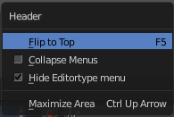
The header has also some right click functionality. Or that you can show or hide a editor type menu where you can switch to other editor types. For this general header functionality, like to show the editor type menu, collapse menus, etc. please have a look at the chapter 2.2 Layouts.

All Modes - View Menu

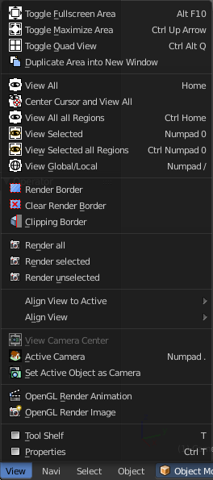
The View menu contains all View related tools. The range goes from tools to maximize the current window across align view tools up to rendering related tools for the viewport like Render Border.

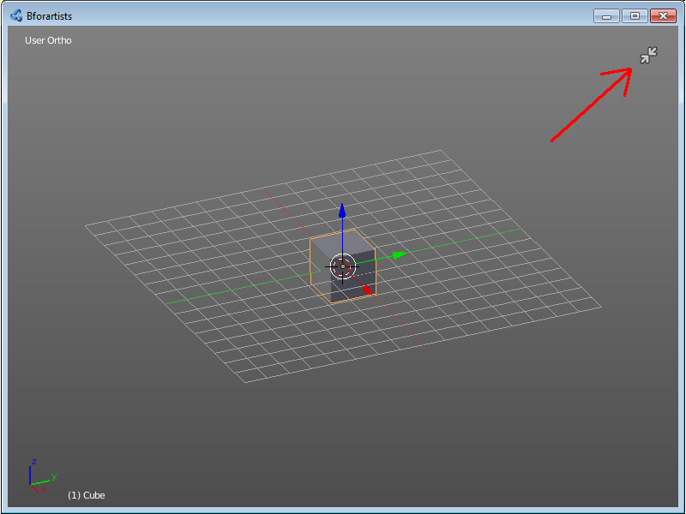
Toggle Full screen Area
Displays the editor maximized without menus.
To return from the full screen view press hotkey Alt F10, or use the little button that appears up right when you move the mouse in this corner.

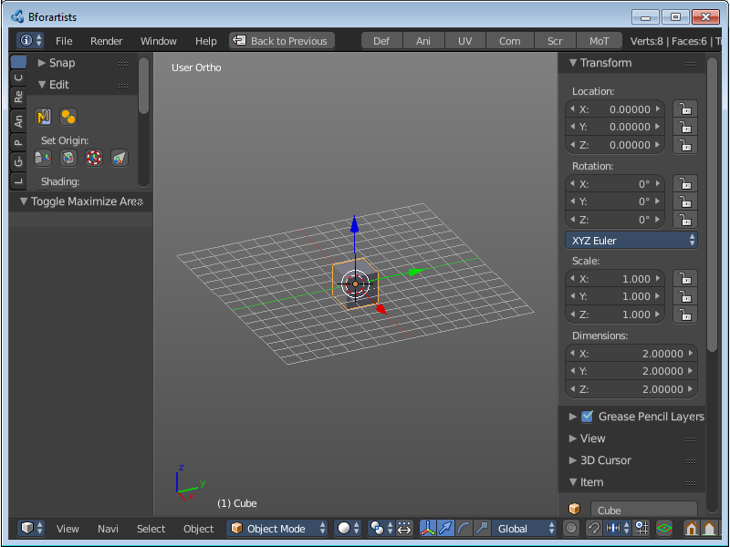
Toggle Maximize Area
Displays the editor maximized with menus.
To return to split view press hotkey Ctrl Up Arrow, or reuse the menu item in the View menu.

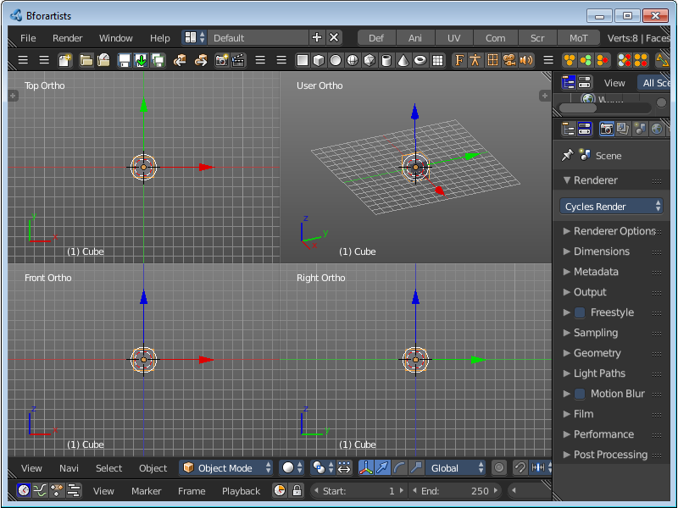
Toggle Quad view
Displays the 3D View divided into four screen parts.
To return to single view reuse the menu item in the View menu.

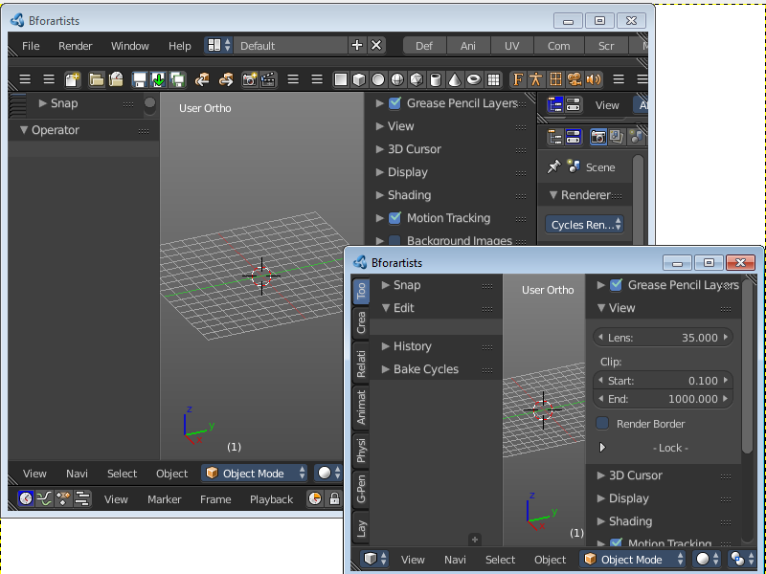
Duplicate Area into New Window
Duplicate Area into New Window makes the selected editor window floating. You can then drag it around at the monitor.
A separated window cannot be merged into the main window again. You have to close it when not longer needed.

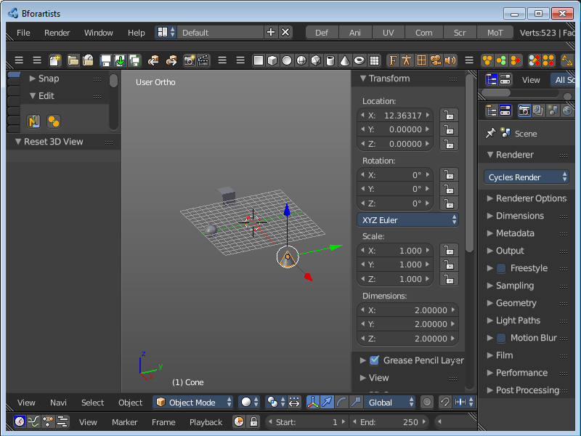
View All
View all zooms in or out until all objects in the scene are displayed fitting in the viewport.

Center Cursor and View All
Center Cursor and View all centres the 3D Cursor at 0/0/0, and zooms in or out until all objects in the scene are displayed fitting in the viewport.

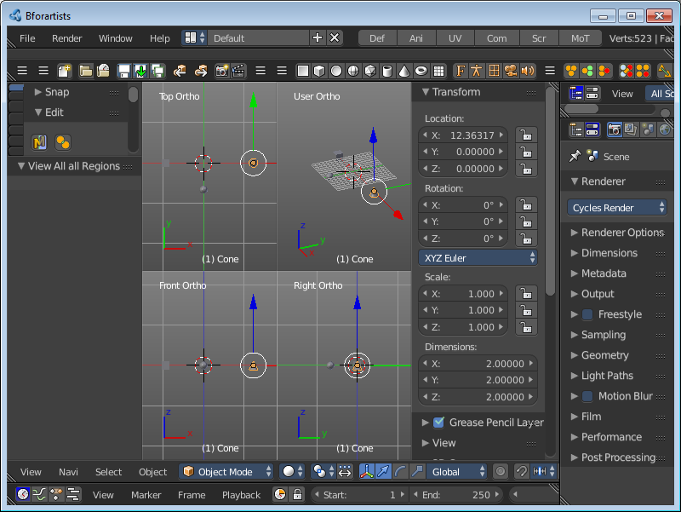
View All all Regions
View All all Regions works just in Quad View. It zooms in or out until all objects in the scene are displayed fitting in the four divided parts of the viewport.

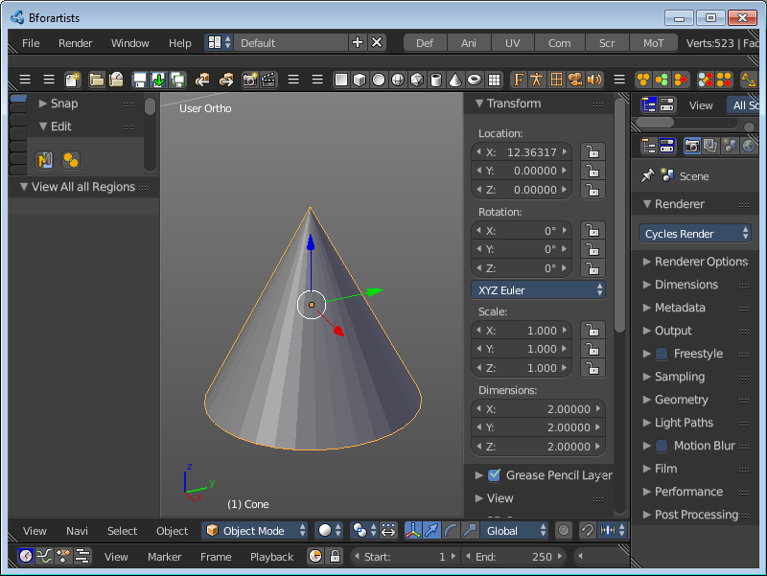
View Selected
View Selected zooms in or out until the Selection is displayed fitting in the viewport.

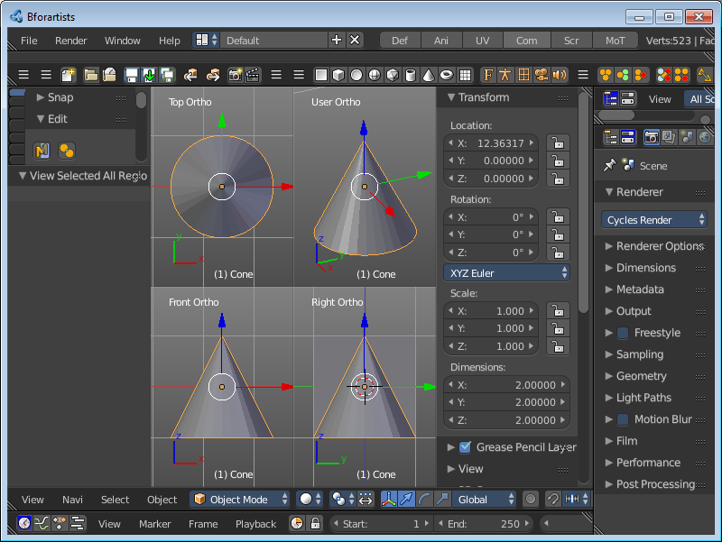
View Selected All Regions
View Selected all Regions works just in Quad View. It zooms in or out until the Selection in the scene are displayed fitting in the four divided parts of the viewport.

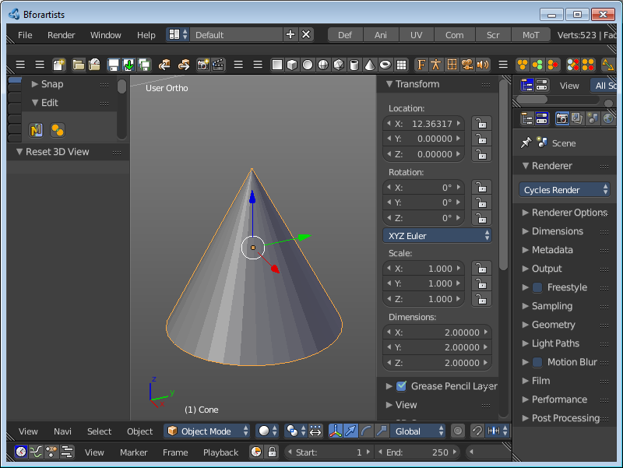
View Global / Local
View Global / Local zooms in or out until the Selection is displayed fitting in the viewport. And hides all other objects but the Selection.

Render Border
With the Render Border you can drag a rectangle at the viewport to define a portion of the screen to render. The benefit here is to have much faster preview renderings. You just render what you want to judge, and not the whole image.
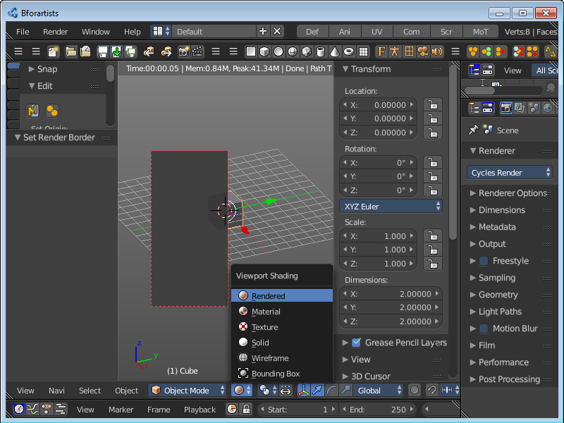
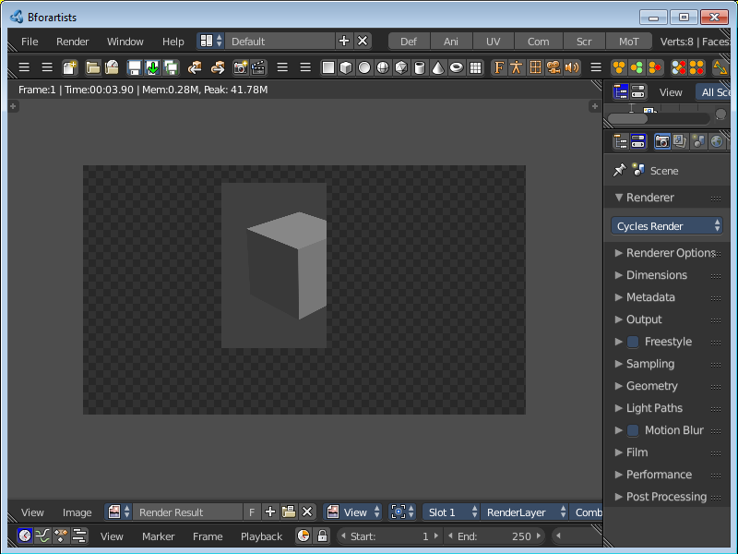
It has two use cases. The one is with the rendering through the camera. Just what is marked gets rendered. The other is directly in the viewport, with the Viewport shading method Rendered.

Clear Render Border
Removes the Render Border from the viewport.

Clipping
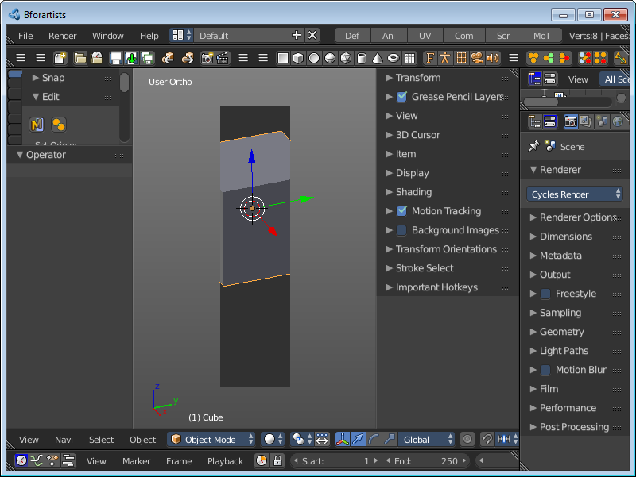
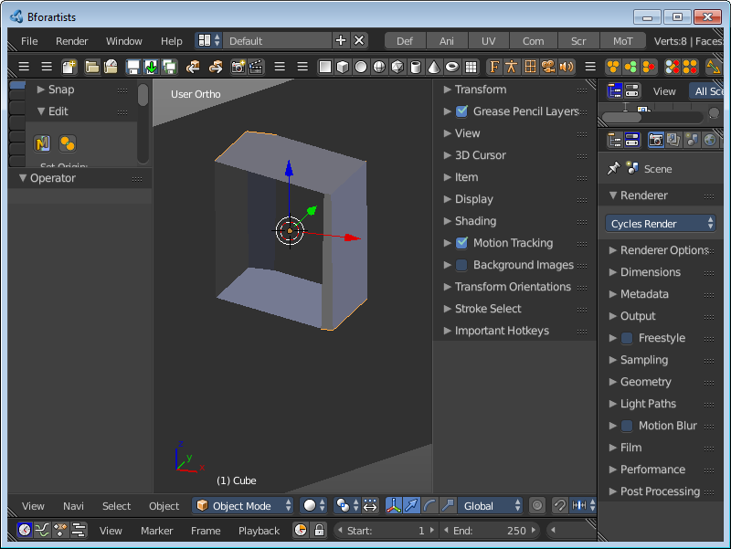
With clipping you can draw a rectangle that excludes the display of everything outside of this rectangle. That way you can look inside the geometry when you rotate the viewport. To clear the clipping use the tool again.

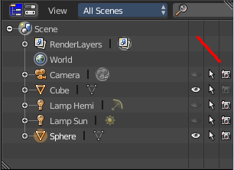
Clear All Restrict Render
Sets all Objects in the scene to be rendered. Have a look in the outliner, the camera row at the right.
This menu option just appears when there is a render able object in the viewport.

Restrict Render Unselected
Sets all unselected Objects in the scene to be rendered. The selected object(s) will be excluded from rendering now. Have a look in the outliner, the camera row at the right.
This menu option just appears when there is a render able object in the viewport

Set Restrict Render
Sets the selected Objects in the scene to be rendered. The unselected objects will be excluded from rendering now. Have a look in the outliner, the camera row at the right.
This menu option just appears when there is a render able object in the viewport

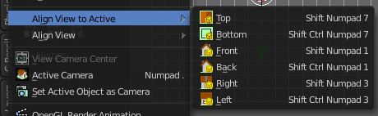
Align View to Active
Align View to Active is a menu where you can choose between different view align methods. The view gets aligned relative to the rotation of the currently active object. Not in World coordinates. The menu items should be self explaining. So we won't list them one by one.

Align View
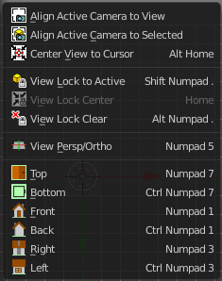
Align View is a menu where you can choose between different view align methods. The view gets aligned at the world coordinates. Here we also find a few more align methods.

Align Active Camera to View
Aligns the active camera to the current view. This means you can navigate with the viewport camera, select the render camera, and align it with this tool, so that the render camera has the same position and angle than the viewport camera.

Align Active Camera to Selected
Aligns the active camera to the current selected object. This means you can navigate with the viewport camera, select the render camera, and align it with this tool, so that the render camera has the same position and angle than the selected object.

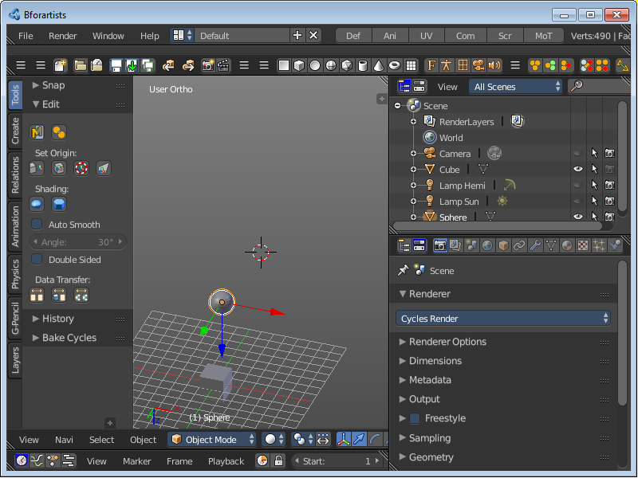
Center View to Cursor
Centres the view at the 3D cursor position.

View Lock to Active
Locks the view to the currently active object.

View Lock Center
Centres the view to the currently active and locked object. This tool is just active when you have performed a View Lock to Active before.

View Lock Clear
Removes the View Lock to Active from the object.

View Persp/Ortho
Toggles between perspectivic and orthographic view. Perspectivic view acts like a real camera with the perspectivic distortions. Orthographic view acts like a mathematical display of an object, without distortions.
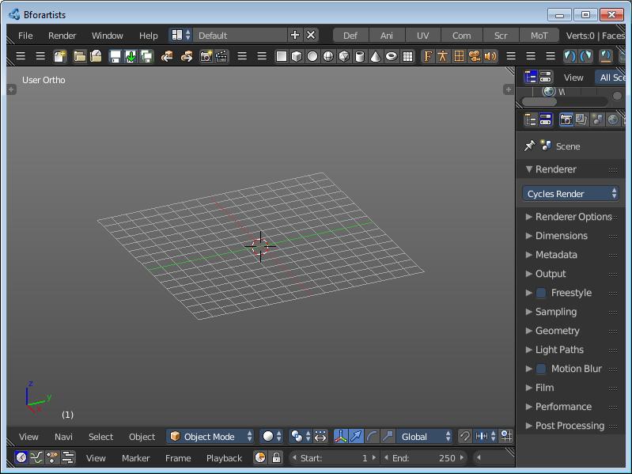
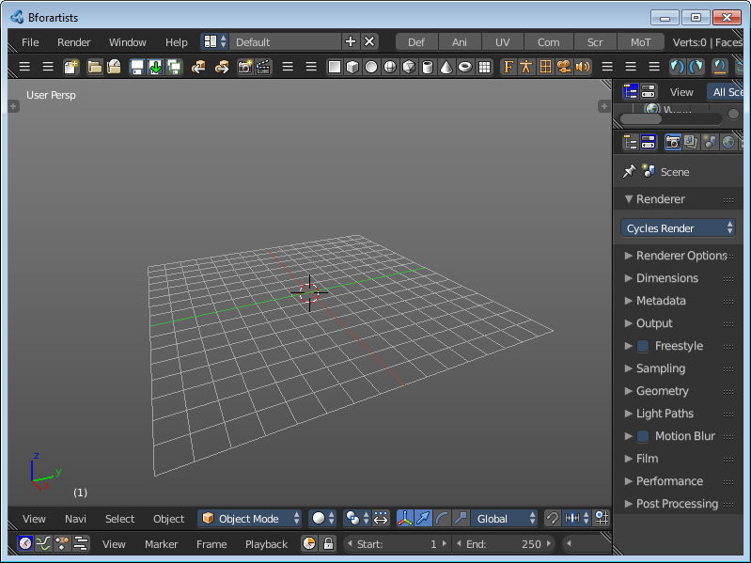

Top, Bottom, etc.
Switches to Top view, Bottom View, etc.

View Camera Center
This tool is of use when you are in camera view. It can be that the passepartout around the actual camera view field does not fit into the viewport. It can be too big or too small. It's already enough to resize the Tool shelf at the left or the Properties Sidebar at the right. And then it doesn't fit anymore.
View Camera center fits the camera view into the viewport.
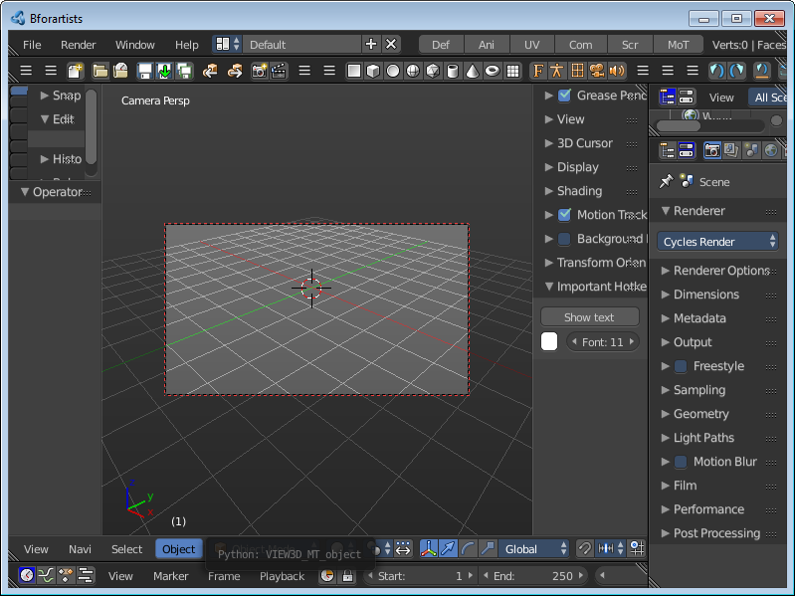
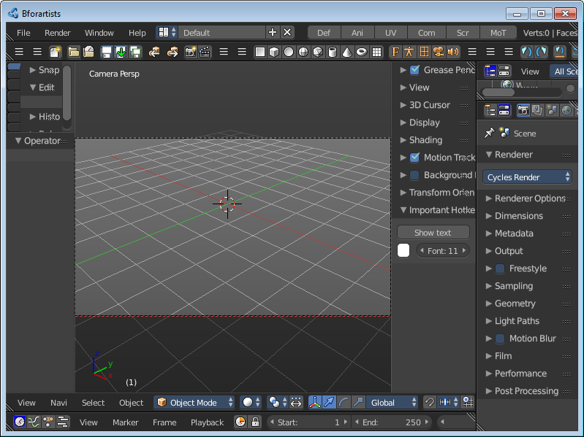

Active Camera
Switches to Camera view and back to Viewport Camera.

Set Active Object as Camera
With this tool you can set any object to be the active camera where you render from.

OpenGL Render Animation
Renders an animation, using the Viewport OpenGL renderer. This can be useful for preview renderings.
Note
Note that this menu item is a double menu entry. The same menu item exists in the Render menu in the Info Header. But this is required when you work with more than one 3D view. When you use the entry in the Render menu, then it picks an arbitrary 3D view. When you use the menu entry in the 3D view, then it renders from this 3D view.

OpenGL Render Image
Renders an Image, using the Viewport OpenGL renderer. This can be useful for preview renderings.
Note
Note that this menu item is a double menu entry. The same menu item exists in the Render menu in the Info Header. But this is required when you work with more than one 3D view. When you use the entry in the Render menu, then it picks an arbitrary 3D view. When you use the menu entry in the 3D view, then it renders from this 3D view.

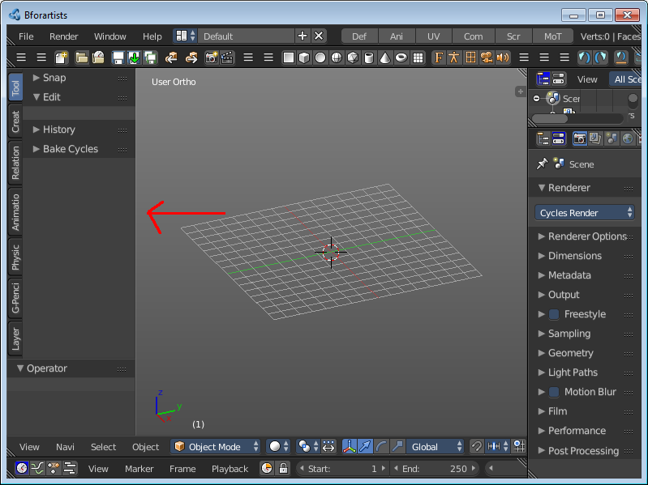
Tool Shelf
Opens or closes the Tool Shelf at the left side of the 3D Viewport.

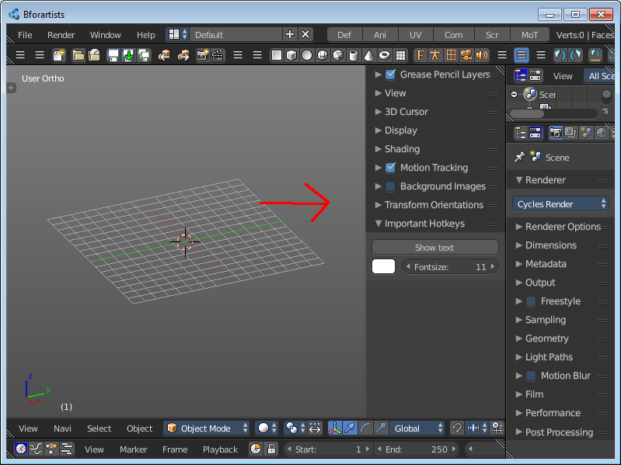
Properties
Opens or closes the Properties sidebar at the right side of the 3D Viewport.

All Modes - Navigation Menu
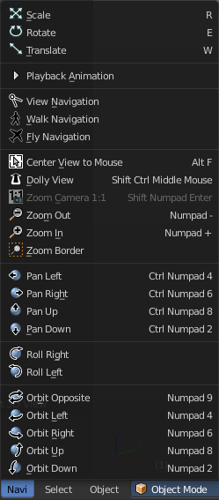
The Navigation menu provides you with all tools around viewport navigation.

Scale
Scales the selected object in the viewport by moving the mouse.

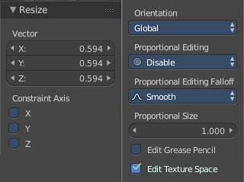
Last Operator Resize

Vector
Here you can adjust the position values for the three values

Constraint Axis
Here you can limit the position relative to the source object.

Orientation

Orientation is a drop-down box where you can choose the type of orientation for the mirroring action.

Proportional Editing

Proportional Editing is a drop-down box where you can choose to use proportional editing. When you choose one of the active methods then the neighbour geometry gets influenced by Shrink/Fatten too in a proportional way.

Proportional Editing Falloff

Proportional Editing Falloff is a drop-down box where you can choose a method for the falloff for the proportional editing.

Proportional Size
Proportional size is a edit box where you can adjust the strength of the Proportional falloff.

Edit Grease Pencil
Edit Grease Pencil edits the selected Grease Pencil strokes.

Edit Texture Space
With Confirm on Release checked the action gets performed when you release the mouse button.

Rotate
Rotates the selected object in the viewport by moving the mouse.

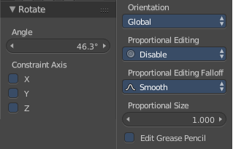
Last Operator Translate

Angle
Here you can adjust the rotation angle.

Constraint Axis
Here you can limit the position relative to the source object.

Orientation
Orientation is a drop-down box where you can choose the type of orientation for the mirroring action.

Proportional Editing
Proportional Editing is a drop-down box where you can choose to use proportional editing. When you choose one of the active methods then the neighbour geometry gets influenced by Shrink/Fatten too in a proportional way.

Proportional Editing Falloff
Proportional Editing Falloff is a drop-down box where you can choose a method for the falloff for the proportional editing.

Proportional Size
Proportional size is a edit box where you can adjust the strength of the Proportional falloff.

Edit Grease Pencil
Edit Grease Pencil edits the selected Grease Pencil strokes.


Translate
Moves the selected object in the viewport by moving the mouse.

Last Operator Translate

Vector
Here you can adjust the position values for the three values

Constraint Axis
Here you can limit the position relative to the source object.

Orientation
Orientation is a drop-down box where you can choose the type of orientation for the mirroring action.

Proportional Editing
Proportional Editing is a drop-down box where you can choose to use proportional editing. When you choose one of the active methods then the neighbour geometry gets influenced by Shrink/Fatten too in a proportional way.

Proportional Editing Falloff
Proportional Editing Falloff is a drop-down box where you can choose a method for the falloff for the proportional editing.

Proportional Size
Proportional size is a edit box where you can adjust the strength of the Proportional falloff.

Edit Grease Pencil
Edit Grease Pencil edits the selected Grease Pencil strokes.

Edit Texture Space
With Confirm on Release checked the action gets performed when you release the mouse button.

Playback Animation
Plays back an existing animation.

View Navigation
Switches to View Navigation Mode. In this view mode the view gets rotated moved and scaled from the Camera view point.

Walk Navigation
Switches to Walk Navigation. In this view mode the camera acts like a player in a first person shooter. Gravity will pull you down, The ground grid is the ground. And you can move around with wasd keys.

Fly Navigation
Switches to Fly navigation. In this view mode the camera acts like an air plane.

Center View to Mouse
Centres the view to the current mouse position.

Dolly View
Dolly View is a special zoom mode.
Be careful with this navigation method, you can easily trap yourself to not zoom able anymore!

Zoom Camera 1:1
Zooms the camera fitting to match the render output size by factor 1:1

Zoom In
Zooms into the viewport. Works also in camera view.

Zoom Out
Zooms out of the viewport. Works also in camera view.

Zoom Border
Draws a rectangle and zooms then to fit the size of this rectangle.
Zooming in is done with drawing the rectangle with left mouse button. Zooming out is done with drawing the rectangle with middle mouse button.

Pan Left
Pans the viewpoint to the left. The scene moves to the right.

Pan Right
Pans the viewpoint to the right. The scene moves to the left.

Pan Up
Pans the viewpoint upwards. The scene moves down.

Pan Down
Pans the viewpoint downwards. The scene moves up.

Roll Right
Rolls the viewport clockwise.

Roll Left
Rolls the viewport counter clockwise.

Orbit Opposite
Rotates the view by 180 degree.

Orbit Left
Orbits to the left.

Orbit Right
Orbits to the right.

Orbit Up
Orbits upwards.

Orbit Down
Orbits downwards.

All Modes, all Object types - Show / Hide

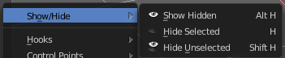
The Show/Hide menu is available for all object types and in all modes. It is usually in the object related menu to find. In Object mode it's the Object menu, for a curve object in edit mode it is the Curve menu. It always contains three menu items. Show Hidden, Hide Selected and Hide Unselected.

Show Hidden
Makes all objects in the scene visible again.

Hide Selected
Hides the selected objects.

Hide Unselected
Hides the not selected objects. The selected object stays visible.

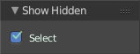
Last Operator Show Hidden
Here you can define if the selected or the unselected objects gets hidden.

Object Mode - Select menu

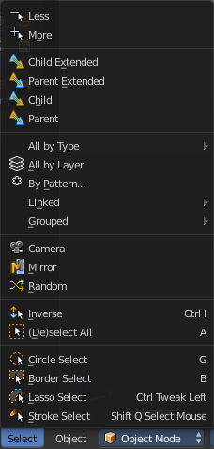
The select menu in Object mode is for all object types equal. It provides you with several selection methods.

Less
Less requires to have a parent or child relationship. It reduces the selection.

More
More requires to have a parent or child relationship. It expands the selection.

Child Extended
Child Extended requires to have a parent or child relationship. It selects the child object(s) of the currently selected object(s). But keeps the active object in the selection, even when it's not currently selected.

Parent extended
Parent extended requires to have a parent or child relationship. It selects the parent object of the currently selected object(s). But keeps the active object in the selection, even when it's not currently selected.

Child
Child requires to have a parent or child relationship. It selects the child object(s) of the currently selected object(s).

Parent
Parent requires to have a parent or child relationship. It selects the parent object of the currently selected object(s).

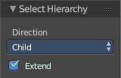
Last Operator Select Hierarchy
Child Extended, Parent Extended, Child and Parent share the same Last Operator. Called Select Hierarchy.

Direction
Direction is a drop-down box where you can adjust if child or parent objects gets selected.

Extended
This checkbox defines if the selection is extended or not. Extended means that it keeps the active object in the selection, even when it's not currently selected.

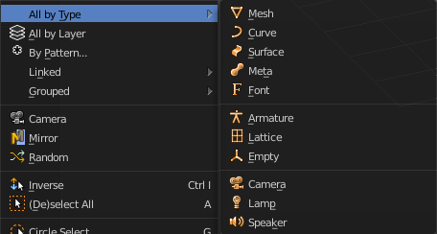
All by Type
All by Type is a menu where you can choose between the different object types to select.
The menu items are pretty self explaining. So we won't cover every single menu item here.

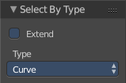
Last Operator Select By Type

Extend
With this option activated the selection does not clear before performing the selection operation, but extends. This means when you have a mesh object selected, and want to select all objects by type curve, then the mesh object is still selected. Without Extend just the curve objects are selected. The mesh object gets deselected.

Type
Type is a drop-down box where you can choose the object type to select again.

All by Layer
Selects all object in the defined layer.
You need to define the layer in the last operator panel. It's not enough to switch to let's say layer three, then perform the tool. The default value is Layer 1.

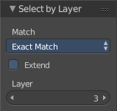
Last Operator Select by Layer

Match
Match is a drop-down box where you can choose if you want to select the objects that just exists at the current layer only. This is the option Exact Match. Or if you want to select objects too that exists at more than one layer. This is the option Shared Layers.

Extend
Extends existing selection instead of deselecting everything first.

Layer
The edit box where you can define the layer where you want to select the objects at.

By Pattern
Selects all objects whose name matches the entered string. For missing parts you need to add an asterix.
For example, you have four cubes in the scene. Cube, Cube.001, Cube.002 and mycube3. Then the term " Cube " will just select the first cube. While the term " Cube* " will select the first three. And " *cube* " will select all four.
Supported wild-cards:
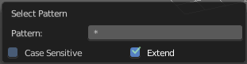
* matches everything
? matches any single character
[abc] matches characters in “abc”
[!abc] match any character not in “abc”
The tool operates immediately at entering the string.

Pattern
Here you can type in your string.

Case Sensitive
When ticked then the string comparison happens by taking upper and lower letters into account.

Extend
Extends existing selection instead of deselecting everything first.

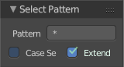
Last Operator Select Pattern
The Last Operator Select Pattern contains the same menu items than the pop-up.

Pattern
Here you can type in your string.

Case Sensitive
When ticked then the string comparison happens by taking upper and lower letters into account.

Extend
Extends existing selection instead of deselecting everything first.

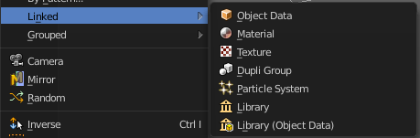
Linked
Linked is a menu where you can select different types.
Here you can select all objects that shares a common data-block with the active object. Select Linked uses the active object as a basis to select all others.

Object Data
Selects every object that is linked to the same Object Data.

Material
Selects every object that is linked to the same material data-block.

Texture
Selects every object that is linked to the same texture data-block.

Dupligroup
Selects all objects that use the same Group for duplication.

Particle System
Selects all objects that use the same Particle System.

Library
Selects all objects that are in the same Library

Library (Object Data)
Selects all objects that are in the same Library and limited to object data.

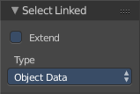
Last Operator Select Linked

Extend
Extends existing selection instead of deselecting everything first.

Type
Type is a drop-down list where you can choose the Linked type again.

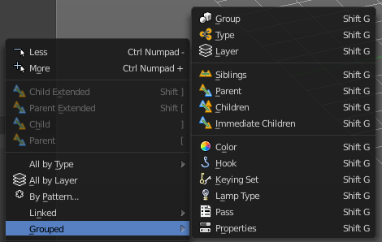
Grouped
Grouped is a menu where you can select different types of objects within the group. It requires to have a group selected.
The menu items are pretty self explaining. So we won't go into detail here.

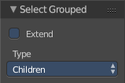
Last Operator Select Grouped

Extend
Extends existing selection instead of deselecting everything first.

Type
Type is a drop-down list where you can choose the Linked type again.

Camera
Selects the active camera.

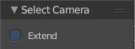
Last Operator Select Camera

Extend
Extends existing selection instead of deselecting everything first.

Mirror
Select the mirrored parts of an object. For example for L.Sword it selects R.Sword.

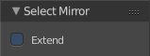
Last Operator Select Mirror

Extend
Extends existing selection instead of deselecting everything first.

Random
Selects random objects.

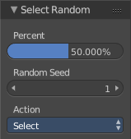
Last Operator Select Random

Percent
The Percentage of objects that should be selected randomly.

Random Seed
The Seed for the random number generator.

Action
Action is a drop-down box where you can choose if you want to select or to deselect random.

Inverse
Inverts the current selection.

(De)Select All
Toggles between select all and deselect all.

Last Operator (De)Select All

Action
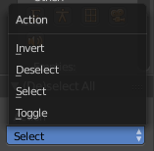
Action is a drop-down box where you can choose between different methods.

Invert
Inverts the selection.

Deselect
Deselects all.

Select
Selects all.

Toggle
Toggles between select all and deselect all.

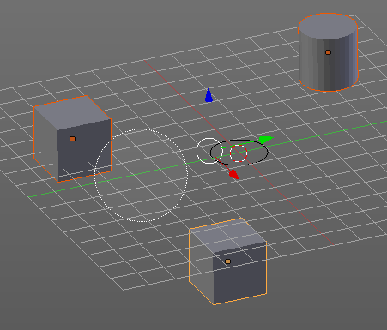
Circle Select
Circle select enters the Circle Select mode. This is a special select mode where you can select elements by moving with the mouse over it. It adds to selection by default.
To subtract from selection hold down Shift key. To exit the Circle select click with the right mouse button.
The pencil radius of the circle select tool can be adjusted with the scroll wheel.

Note
You cannot navigate while you are in Circle Select mode. You have to leave the Circle Select mode, do the navigation, then re-enter the Circle Select mode.

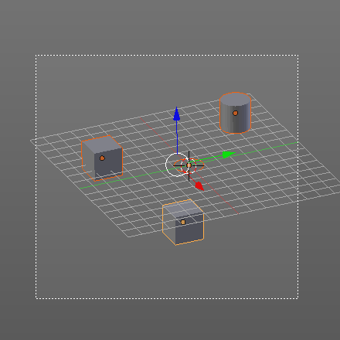
Border Select
Border select enters the Border Select mode. This is a special select mode where you can select elements by dragging a rectangle. And what's inside of the rectangle gets selected then. It adds to selection by default.
To subtract from selection hold down Shift key.
The selection gets applied when you release the mouse. You leave the mode automatically when you release the mouse.

Lasso Select
Lasso select enters the Lasso Select mode. This is a special select mode where you can select elements by dragging a form around what you want to select. And what's inside of the rectangle gets selected then. It adds to selection by default.
To subtract from selection hold down Shift key.
The selection gets applied when you release the mouse. You leave the mode automatically when you release the mouse.

Note
You can of course also start with clicking at the menu item. But this tool is by design a hotkey only tool. Hold down Ctrl , and select with left mouse button.

Stroke Select
Stroke select enters the Stroke Select mode. This is a special select mode where you can select elements by moving with the mouse over it. It is somehow similar to the Circle select tool. But has no pencil size. At the contrary, here you can navigate while you are in stroke select mode.
It adds to selection by default. To subtract from selection right click to change to deselect mode. This can also be done in the Properties sidebar in the Stroke Select panel. To return to add to selection right click again. Or untick the menu item in the Stroke Select Panel.
Note
This tool is by design a hotkey only tool. Hold down the key combo Shift Q, and paint with left mouse button.

Stroke Select is an add-on, and can be uninstalled if wanted. But note that the functionality is not longer available then.
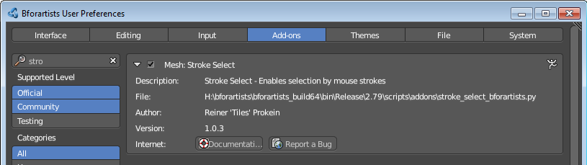

Object Mode - Object menu
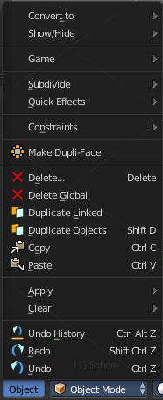
The object menu in Object mode provides you with tools to work at Object level.

It contains things like undo redo, copy and paste, delete and other general tools. But also some object specific tools, like the Convert to menu.

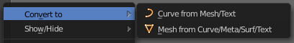
Convert to
Convert to is a menu to convert curves object types to mesh objects, and mesh object types to curves.

Curve from Mesh/Text
Converts a selected Mesh or Text Object to a Curve Object.

Mesh from Curve/Meta/Surf/Text
Converts a selected Curve, Metaball, Surface or Text Object to a Mesh Object.

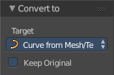
Last Operator Convert to
Target is a drop-down box where you can again choose between the two convert methods.
Keep Original
With this option ticked the original object gets kept. And a new object gets created.

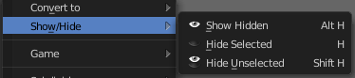
Show/Hide
Show/Hide is a menu. Here you can show or hide objects in the viewport. See chapter All Modes, all Object types - Show / Hide

Game
Game is a menu that is related to the Blender Game Engine. Bforartists does not give any support for the Game Engine. Please head over to the Blender Manual when you want to learn more about this menu.

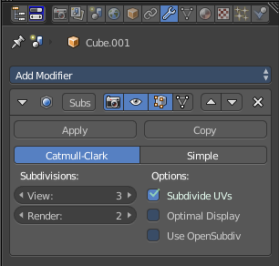
Subdivide
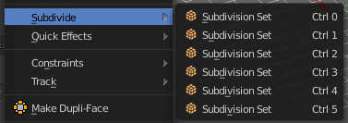
Subdivide is a menu where you can quickly add and change a subdivision surface modifier with a predefined resolution in a quick way. Especially when you use the hotkey for it. The subdivision surface modifier panel can then as usual be found in the Properties editor in the Modifier tab.

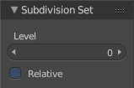
Last Operator Subdivision Set

Level
Here you can set the level of subdivisions

Relative
Applies the sub surf level as an offset to the already existing sub surf level.

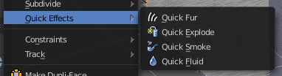
Quick Effects
Quick effects is a menu with some predefined basic Particle effects. You need to have a mesh object selected.

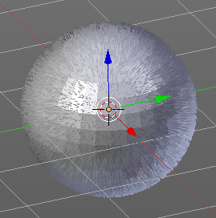
Quick Fur
Adds a particle system with Fur settings.

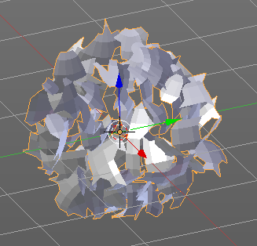
Quick Explode
Adds a particle system that lets the selected object explode into pieces.
Hit play to play the animation.

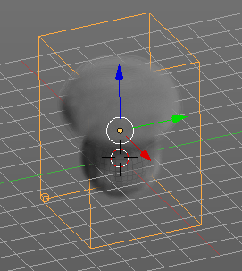
Quick Smoke
Adds a particle system with a simple smoke.
Hit play to play the animation.

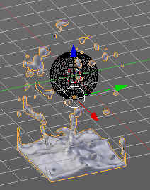
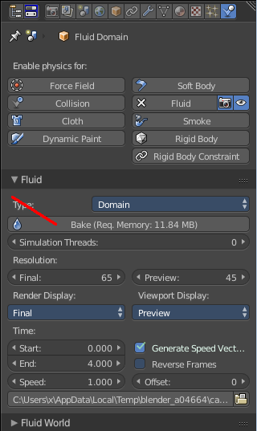
Quick Fluid
Adds a particle system with Fluid settings.
This feature does not completely work out of the box. You need to bake the animation first. This can be done in the Properties Editor, Particles Tab, Fluid Panel.

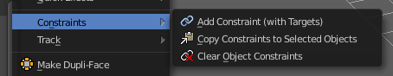
Constraints
Constraints is a menu around Constraints functionality. Constraints provides you with various limitation methods connected to a target object. For example, you can limit the X position of an object to the X position of the target object. And when you move the target object, then the object will change its X position too.

Add Constraints ( With Targets)
Add Constraints ( With Targets) calls a menu where you can choose the constraints type. It's the same content than in the Constraints tab in the Properties editor.
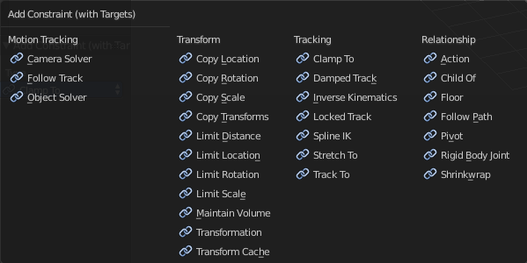
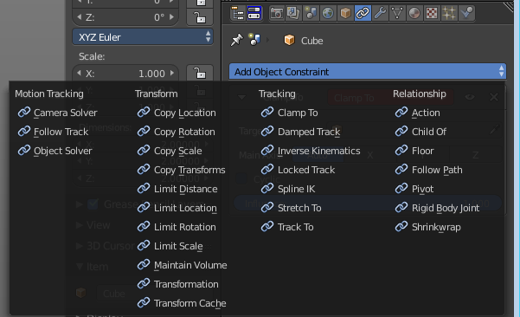

We will not explain every single constraint type here. Please have a look at the constraint types in the manual part for the Properties editor.
Usage:
Select the target object. Hold down Shift key. Now select the object where you want to add the constraints to. Both should be selected. Then choose the constraints type in the menu that you want to add.
As a result a constraints panel gets created in the Constraints tab in the Properties editor. Here you can tweak the settings then further if required. In our example we wanted to limit the X axis. So we added a Copy Location constraint, and unticked Y and Z axis.
In the 3D view a black dotted line indicates the relationship.
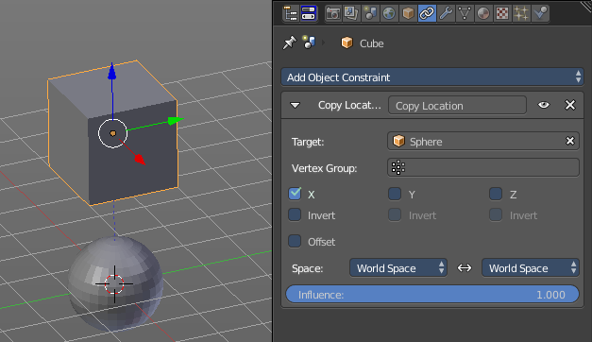

Last Operator Add Constraints (with Target)

Type
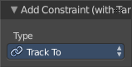
Type is a drop-down box where you can choose the constraints type again.

Copy Constraints to Selected Objects
Copy Constraints to Selected Objects copies a constraint from one object to another.
Usage:
Select the object where you want to copy the constraint to. Hold down Shift and select the object with the constraint. Both should be selected. Then click at Copy Constraints to Selected Objects. This copies the constraint to the object.

Clear Object Constraints
Removes all constraints from the object.

Clear Track
This menu item is just relevant when you have a Track constraint applied. It removes the track constraint.

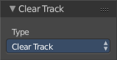
Last Operator Clear track

Type
Type is a drop-down box where you can choose between Clear Track and Clear Track Keep Transformation.

Clear Track - Keep Transformation
This menu item is just relevant when you have a Track constraint applied. Removes the track constraint. But keeps the current position.

Last Operator Clear track

Type
Type is a drop-down box where you can choose between Clear Track and Clear Track Keep Transformation.

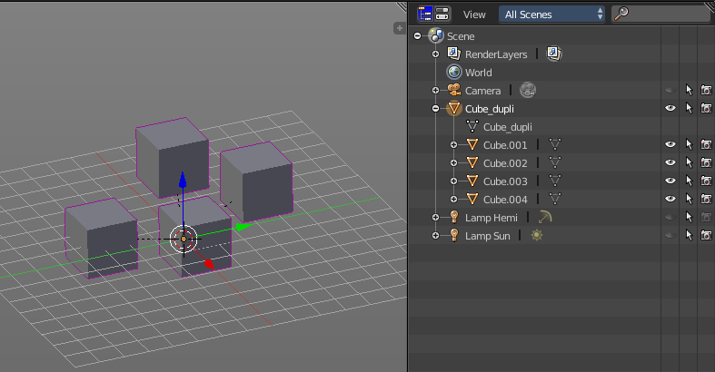
Make Dupli Face
Make Dupli Face is a relict from the past, when there was no instancing or parenting feature available in Blender. When you turn an object into a Dupli Face object, then this object becomes an instancing container for this object. All objects in this container just exists once in ram when you duplicate it. No matter how often you duplicate it. This allows to plant whole forests without to run into a memory problem. Since the tree object just loads once into ram. And gets just drawn at different screen positions then.

Delete
Delete deletes the selected object(s)

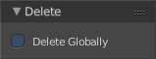
Last Operator Delete

Delete Globally
When ticked then the delete operation deletes global, in all scenes.

Delete Global
It can be that you have more than one scene open. Delete deletes the selected object(s) in all scenes.

Last Operator Delete

Delete Globally
When ticked then the delete operation deletes global, in all scenes.

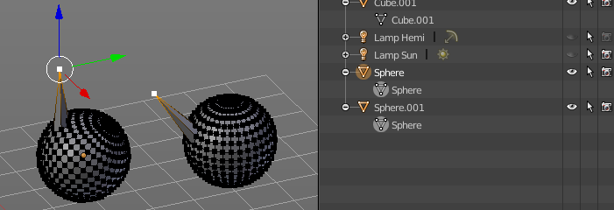
Duplicate Linked
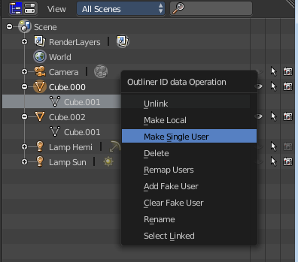
Duplicates selected objects. The instance has its own transforms. But the duplicate shares some data with the first instance. This means when you for example edit the mesh of one of the instances, then the other instance gets modified too. As you can see this in the screen shot. Here you can also see that the mesh name is the same.
If you want to make changes to an object in the new linked duplicate independently of the original object, then you will have to manually make the object a “single-user” . This can be done for example in the Outliner, in the right click menu of the object.
You are automatically in grab mode, and so you can easily move the object out of position. which is sometimes wanted, since you can position the duplicate then. But sometimes this is unwanted. A right click after releasing the mouse lets the object snap back into its creation position.
Duplicate linked instances the object data.
Explanation: Each Bforartists object type (mesh, lamp, curve, camera etc.) is composed from two parts: an Object and Object Data (sometimes abbreviated to ObData):
Object - Holds information about the position, rotation and size of a particular element.
Object Data - Holds everything else. For example. Meshes stores geometry, material lists, vertex groups, etc. . Cameras stores focal length, depth of field, sensor size, etc. .
Each object has a link to its associated object-data, and a single object-data may be shared by many objects.

Hint
If you want to make changes to an object in the new linked duplicate independently of the original object, you will have to manually make the object a “single-user” copy by LMB the number in the Object Data panel of the Properties Window.

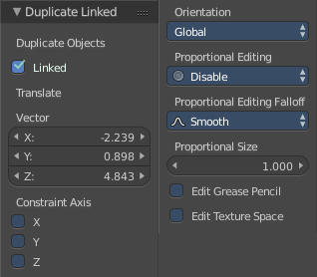
Last Operator Duplicate Linked

Duplicate Objects

Linked
With this option ticked the duplication happens with linked data.

Translate
The Position of the duplicated object

Constraint Axis
Here you can limit the position relative to the source object.

Orientation
Orientation is a drop-down box where you can choose the type of orientation for the mirroring action.

Proportional Editing
Proportional Editing is a drop-down box where you can choose to use proportional editing. When you choose one of the active methods then the neighbour geometry gets influenced by Shrink/Fatten too in a proportional way.

Proportional Editing Falloff
Proportional Editing Falloff is a drop-down box where you can choose a method for the falloff for the proportional editing.

Proportional Size
Proportional size is a edit box where you can adjust the strength of the Proportional falloff.

Edit Grease Pencil
Edit Grease Pencil edits the selected Grease Pencil strokes.

Edit Texture Space
With Confirm on Release checked the action gets performed when you release the mouse button.

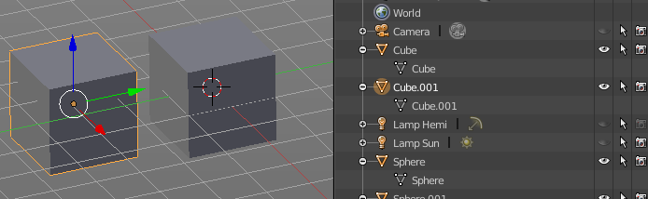
Duplicate Objects
Duplicates selected objects. The copy is completely independent. All containing data gets duplicated too. And you can edit the object instances completely independent. then.
You are automatically in grab mode, and so you can easily move the object out of position. Which is sometimes wanted, since you can position the duplicate then. But sometimes this is unwanted. A right click after releasing the mouse lets the object snap back into its creation position.
When you drag the duplicate around you will see the position values in the header.

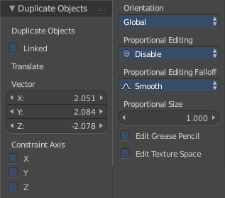
Last Operator Duplicate

Duplicate Objects

Linked
With this option ticked the duplication happens with linked data.

Translate
The Position of the duplicated object.

Constraint Axis
Here you can limit the position relative to the source object.

Orientation
Orientation is a drop-down box where you can choose the type of orientation for the mirroring action.

Proportional Editing
Proportional Editing is a drop-down box where you can choose to use proportional editing. When you choose one of the active methods then the neighbour geometry gets influenced by Shrink/Fatten too in a proportional way.

Proportional Editing Falloff
Proportional Editing Falloff is a drop-down box where you can choose a method for the falloff for the proportional editing.

Proportional Size
Proportional size is a edit box where you can adjust the strength of the Proportional falloff.

Edit Grease Pencil
Edit Grease Pencil edits the selected Grease Pencil strokes.

Edit Texture Space
With Confirm on Release checked the action gets performed when you release the mouse button.

Copy
Copies the selected object(s)

Paste
Pastes copied object(s).

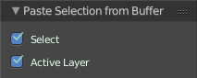
Last Operator Paste Selection from Buffer

Select
Select pasted object(s).

Active Layer
Paste the object into the active layer.

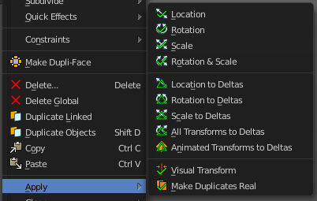
Apply
Apply is a menu where you can apply transforms in various combinations. For example, when you create a cube, then move it to let's say 3, then apply the location, then the origin gets set to 0. The position is "applied". Of special Interest is apply scale, since it resets the scale factor to 1.
Apply just works with single user objects. And it does not apply to pose position, animation curves or constraints. These tools should be used before rigging and animation.

Location, Rotation, Scale and Rotation&Scale
This applies the location, rotation and scale of the object.

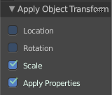
Last Operator Apply Object Transform.

Location
Applies the position, and resets origin to 0

Rotation
Applies the rotation.

Scale
Applies the Scale.

Apply Properties
Properties such as Curve Vertex Radius. Font Size and bone envelope gets applied.

Location, Rotation, Scale and All Transforms to Deltas
Transforms are absolute to the world coordinates. Delta Transforms are relative to the current transformation.
The delta transform values can be found in the Object properties, in the Delta Transform Panel.
Example use case:
Keyframe a object rotation from 0 to 90 degrees. Rotate the object by 45 degrees. When you play the animation it will still rotate from 0 to 90 degrees.
Now keyframe a delta rotation from 0 to 90 degrees and rotate the object by 45 degrees. When you playback the animation it will rotate from 45 to 135 degrees now. (a 90 degree difference from the current state)

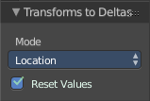
Last Operator Transforms to Deltas

Mode
Mode is a drop-down box where you can choose the transform mode again.

Reset Values
Clears the transform values after transferring to Deltas.

Animated Transform to Deltas
Converts the “normal” transformation animations to Delta transforms. This tool requires to have key frames at the object.

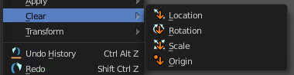
Clear
Clear Transform is a menu where you can clear the transform for location, rotation, scale and Origin. Clear means in this conjunction that the values gets reset. When you have for example a cube at X 5, and clear the location, then the cube gets positioned at position X 0.

Location
Resets the location of the selected object(s).

Last Operator Clear Location

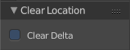
Clear Delta
With Clear Delta ticked it clears the delta transform instead of the transform.

Rotation
Resets the rotation of the selected object(s).

Last Operator Clear Rotation

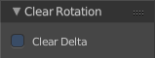
Clear Delta
With Clear Delta ticked it clears the delta transform instead of the transform.

Scale
Resets the scaling of the selected object(s).

Last Operator Clear Scale

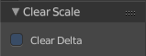
Clear Delta
With Clear Delta ticked it clears the delta transform instead of the transform.

Origin
Clear Origin requires to have a parent child relationship selected. It sets the child object to the position of the parent object.

Edit Mode - Mesh Object - Mesh Menu

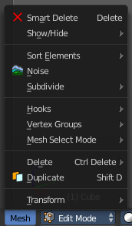
The Mesh Menu in Edit Mode contains the tools to manipulate the mesh geometry in Edit mode. It just exists for Mesh Objects.

Lots of functionality that could also belong here can also be found in the Tool Shelf. The difference is that the tools in the tool shelf are easier to access. And so it contains the most used tools for the daily work. While the Mesh menu contains the not so often used tools. Or tools where you use the hotkey anyway. Delete for example.

Smart Delete
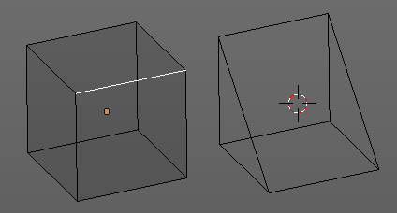
Smart delete deletes what is selected in an intelligent way. When you for example delete an edge then the edge gets deleted. But it also deletes the vertices connected to this edge. It performs a Dissolve operation under the hood.
There is a bit below a Delete menu where you can choose different methods for deleting if required. And the Dissolve tools can be found in the Tool Shelf in the Tools tab.

Show / Hide
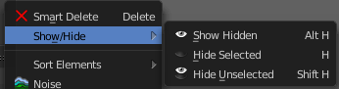
Show / hide is a menu that contains the Show Hide tools. Here you can show or hide your current selection in the viewport. See chapter All Modes, all Object types - Show / Hide

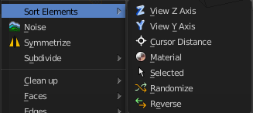
Sort Elements
Sort Elements is a menu with different sorting methods. It allows you to reorder the mesh indices of the selected mesh elements by various methods.

Hint
You can enable the viewing of mesh indices by typing in bpy.app.debug = True in the Python console in the scripting layout. This reveals a checkbox in the Mesh Display panel in the Info Options subsection. And when you tick this checkbox, then the vertices or edges or faces gets displayed with their indices value.
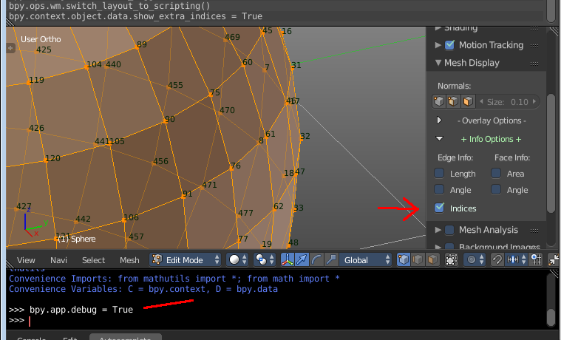

View Z Axis
Sorts along the active view’s Z axis, from farthest to nearest. You can use Reverse if you want it the other way.

View Y Axis
Sorts along the active view’s Y axis, from farthest to nearest. You can use Reverse if you want it the other way.

Cursor Distance
Sorts from nearest to farthest away from the 3D cursor position.

Material
Faces only! Sorts faces by their lowest material index up to highest material index. Order of faces inside each of those material groups remains unchanged.

Note that the Reverse option only reverses the order of the materials. And the order of the faces inside them.

Selected
Moves all selected elements to the beginning without affecting their relative orders. Attention, this option will also affect unselected element indices!

Randomize
Randomizes the indices of selected elements. This option does not affect the unselected elements.

Reverse
Reverses the order of the selected elements.

Last Operator Sort Mesh Elements
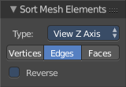
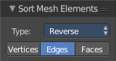
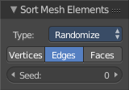
Sort Elements always brings up the same last operator. But with a small difference for Randomize and Reverse. Reverse has no checkbox. And Randomize has a Seed checkbox.

Type
This is a drop-down box where you can choose the sort method again.

Vertices, Edges or Faces
Here you can adjust if the sort will affect the vertices, edges or faces.

Reverse Checkbox
Reverses the sorting.

Seed Edit box (Randomize only)
The seed option allows you to get another randomization – the same seed over the same mesh/set of selected elements will always give the same result!

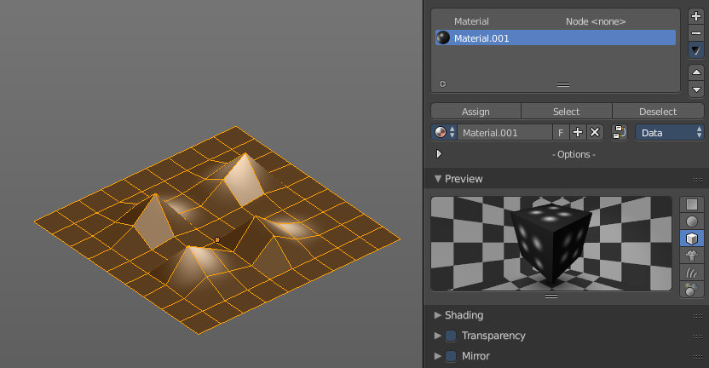
Noise
Noise is a displacement tool where you can use a texture to displace the geometry. It just works with the Blender Internal renderer, and you need to have a texture and a material assigned.
The strength can be adjusted in the Last Operator.

Last Operator Noise

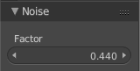
Factor
Here you can adjust the strength of the displacement.

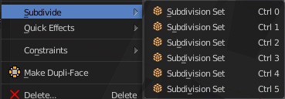
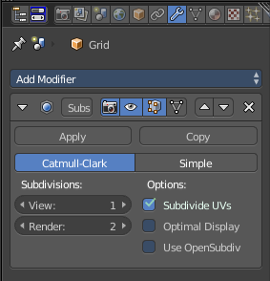
Subdivide
Subdivide is a menu where you can quickly set the subdivision level of the selection.
What it does is to add a SDS modifier in the Properties Editor if required. And set the SDS level to the needed value.
Crtrl 0 sets SDS to level 0. Ctrl 1 sets SDS level to 1 , and so on.
SDS happens at Object mode level. Even when you apply it in the Edit Mode! And it happens at the whole object.

Last Operator Subdivision Set

Level
Here you can adjust the SDS level.

Relative
Applies the Subsurf Level as an offset relative to the current level.

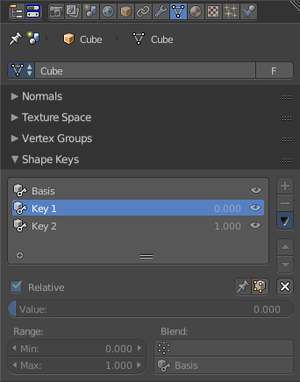
Blend from Shape
This tool requires to have a shape key at the mesh. It blends the selected shape key into the mesh.

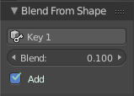
Last Operator Blend from Shape

Drop-down box
Here you can define which shape key should be used.

Blend edit box
Here you can adjust the blend factor

Add
Add to blend shape instead of blending in.

Shape Propagate
This tool requires to have a shape key at the mesh. It applies the current vertex locations to all other shape keys at the mesh.

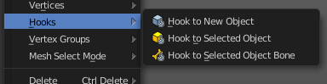
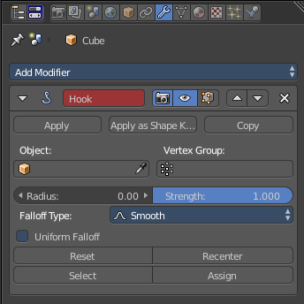
Hooks
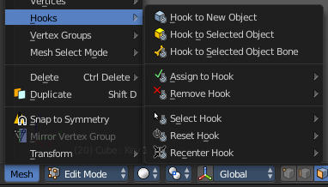
Hooks is a menu with tools around the hook modifier. You could also adjust the hook modifier from the Properties editor. But the menu items are more accessible.
When there is no hook modifier at the mesh then you just see three menu items. When there is minimum one hook modifier applied, then you will see an extended menu.

Hook to New Object
Creates a new Hook Modifier for the active object and assigns it to the selected vertices. It also creates an empty at the center of those vertices, which are hooked to it.

Hook to Selected Object
Does the same as Hook to New Object, but instead of hooking the vertices to a new empty, it hooks them to the selected object (if it exists). There should be only one selected object (besides the mesh being edited).

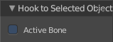
Last Operator Hook to Selected Object

Active Bone
Hook to the object(s) of the active bone.

Hook to Selected Object Bone
Does the same as Hook to New Object. But it sets the last selected bone in the also selected armature as a target.

Assign to Hook
Here you can assign the selected vertices to the chosen hook modifier. Existing hooks gets overwritten. One vertex can be assigned to more than one hook.

Remove Hook
Removes the chosen Hook Modifier from the object.

Select Hook
Selects all vertices assigned to the chosen Hook Modifier.

Reset Hook
Resets the chosen Hook Modifier.

Recenter Hook
Recenter the Hook Modifier.

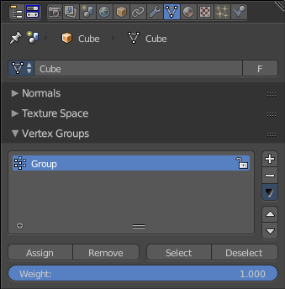
Vertex Groups
Vertex groups is a menu around vertex group functionality. The vertex groups can be found in the Object data tab in the Properties editor.

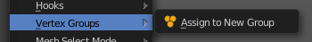
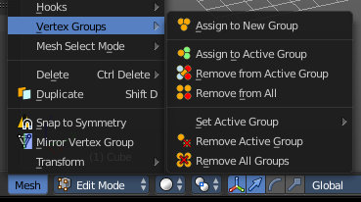
When there is no vertex group assigned yet then you can only see one menu item. The assign to new group button.
Once you have a vertex group assigned you will see the full functionality.

Assign to New Group
Assigns the mesh selection to a new vertex group.

Assign to active Group
Assigns the mesh selection to the currently active vertex group.

Remove from Active Group
Removes the mesh selection from the currently active vertex group.

Remove from All
Removes the mesh selection from all vertex groups.

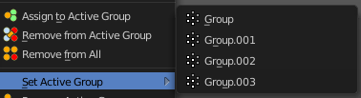
Set Active Group
Here you can select a vertex group to be the active one.

Remove Active Group
Removes the currently active vertex group.

Remove All Groups
Removes all vertex groups from the mesh.

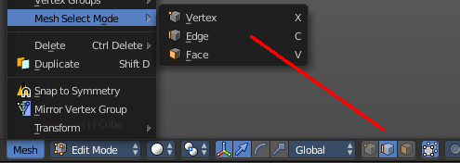
Mesh Select Mode
Mesh Select mode is a sub menu where you can set the current mesh select mode. Its functionality is equal to the mesh select mode buttons in the header. Just that you can't select more than one mode directly here. This menu exists to show and to edit the hotkeys. Not to work with it.
Interestingly the menu items have a last operator. Again, it is not meant to work this way. So this is just listed for documentation reasons.

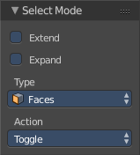
Last Operator Select Mode

Extend
Adds to the current selection mode

Expand
Not documented, not to find out, sorry.

Type
Here you can again adjust what select mode you want to activate

Action
How to work with the operator. Toggle means when you click at the button and it is disabled, then it enables. And vice versa. Enable and disable should be self explaining.

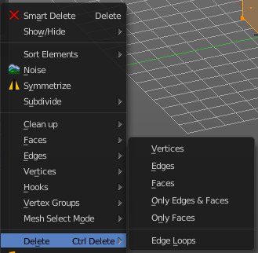
Delete
The smart delete works dependant of the selection and the mode. Which is fine for most cases. This delete menu gives you some more control over what exactly you want to delete. And how you want to delete it.

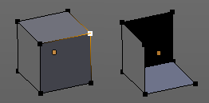
Vertices
Deletes the selected vertices, and all with it connected edges and faces.

Edges
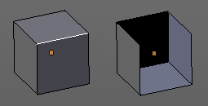
Deletes the selected edges and the connected faces.

Faces
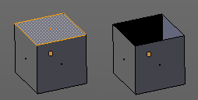
This one works similar to the smart delete. It deletes the selected faces.

Only Edges and Faces
This mode is of interest when you have more than one selection mode activated. It deletes then just the selected edges and faces. And not single vertices.

Only Faces
This mode is of interest when you have more than one selection mode activated. Just selected faces gets deleted. Not single edges or vertices.

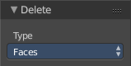
Last Operator Delete
The Last Operator Delete is the same for the above menu items.

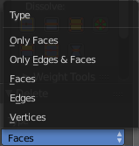
Type
Here you can choose the delete method again.

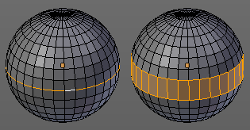
Edge Loops
This method works similar to the smart delete tool. It deletes the edge loop. But it selects the faces of the edge ring. And the Last operator offers you the option to split off face corners.

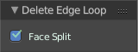

Last Operator Delete Edge Loop

Face Split
Split off face corners to maintain surrounding geometry.

Duplicate
Duplicates the current selection. The copy sticks to the mouse until you release it. A Right click while moving will reset the position of the duplicate. The duplicated part will be part of the same object.
When you drag the duplicate around you will see the position values in the header.

Last Operator Duplicate

Duplicate Objects

Linked
With this option ticked the duplication happens with linked data.

Translate
The Position of the duplicated object

Constraint Axis
Here you can limit the position relative to the source object.

Orientation
Orientation is a drop-down box where you can choose the type of orientation for the mirroring action.

Proportional Editing
Proportional Editing is a drop-down box where you can choose to use proportional editing. When you choose one of the active methods then the neighbour geometry gets influenced by Shrink/Fatten too in a proportional way.

Proportional Editing Falloff
Proportional Editing Falloff is a drop-down box where you can choose a method for the falloff for the proportional editing.

Proportional Size
Proportional size is a edit box where you can adjust the strength of the Proportional falloff.

Edit Grease Pencil
Edit Grease Pencil edits the selected Grease Pencil strokes.

Edit Texture Space
With Confirm on Release checked the action gets performed when you release the mouse button.

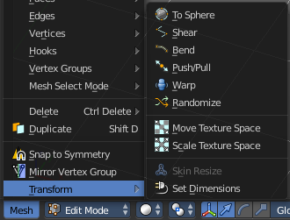
Transform
Transform is a menu that contains some special transform functionality.
See chapter Edit Mode - Transform Menu

Edit Mode - Curve + Surface Object - Curve + Surface Menu
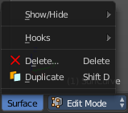
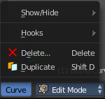
The Curve Menu in Edit Mode contains the tools to manipulate the curve geometry in Edit mode. It just exists for Curve Objects.

Same counts for the Surface Menu in Edit mode. The menus are identical since both object types are a curve type. So we handle both menus here.

Show/Hide
Show/Hide is a menu. Here you can show or hide objects in the viewport. See chapter All Modes, all Object types - Show / Hide

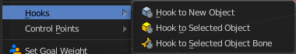
Hooks
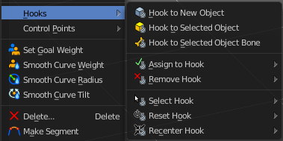
Hooks is a menu with tools around the hook modifier. You could also adjust the hook modifier from the Properties editor. But the menu items are more accessible.
When there is no hook modifier at the mesh then you just see three menu items. When there is minimum one hook modifier applied, then you will see an extended menu.

Hook to New Object
Creates a new Hook Modifier for the active object and assigns it to the selected vertices. It also creates an empty at the center of those vertices, which are hooked to it.

Hook to Selected Object
Does the same as Hook to New Object, but instead of hooking the vertices to a new empty, it hooks them to the selected object (if it exists). There should be only one selected object (besides the mesh being edited).

Last Operator Hook to Selected Object

Active Bone
Hook to the object(s) of the active bone.

Hook to Selected Object Bone
Does the same as Hook to New Object. But it sets the last selected bone in the also selected armature as a target.

Assign to Hook
Here you can assign the selected vertices to the chosen hook modifier. Existing hooks gets overwritten. One vertex can be assigned to more than one hook.

Remove Hook
Removes the chosen Hook Modifier from the object.

Select Hook
Selects all vertices assigned to the chosen Hook Modifier.

Reset Hook
Resets the chosen Hook Modifier.

Recenter Hook
Recenter the Hook Modifier.

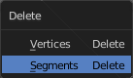
Delete
Delete calls a pop-up where you can choose if you want to delete vertices or segments.

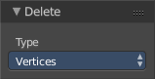
Last Operator Delete

Type
Here you can again choose if you want to delete vertices or segments.

Duplicate
Duplicates the current selection. The copy sticks to the mouse until you release it. A Right click while moving will reset the position of the duplicate. The duplicated part will be part of the same object.
When you drag the duplicate around you will see the position values in the header.

Last Operator Duplicate

Duplicate Objects

Linked
With this option ticked the duplication happens with linked data.

Translate
The Position of the duplicated object

Constraint Axis
Here you can limit the position relative to the source object.

Orientation
Orientation is a drop-down box where you can choose the type of orientation for the mirroring action.

Proportional Editing
Proportional Editing is a drop-down box where you can choose to use proportional editing. When you choose one of the active methods then the neighbour geometry gets influenced by Shrink/Fatten too in a proportional way.

Proportional Editing Falloff
Proportional Editing Falloff is a drop-down box where you can choose a method for the falloff for the proportional editing.

Proportional Size
Proportional size is a edit box where you can adjust the strength of the Proportional falloff.

Edit Grease Pencil
Edit Grease Pencil edits the selected Grease Pencil strokes.

Edit Texture Space
With Confirm on Release checked the action gets performed when you release the mouse button.

Edit Mode - Metaball Object - Metaball Menu
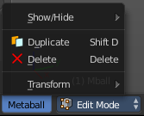
The Metaball menu in Edit mode contains the tools to work with Meta elements in Edit Mode.

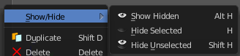
Show/Hide
Show/Hide is a menu. Here you can show or hide objects in the viewport. See chapter All Modes, all Object types - Show / Hide

Duplicate
Duplicates the current selection. The copy sticks to the mouse until you release it. A Right click while moving will reset the position of the duplicate. The duplicated part will be part of the same object.
When you drag the duplicate around you will see the position values in the header.

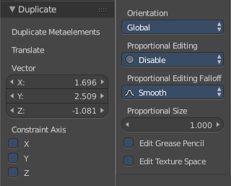
Last Operator Duplicate

Duplicate Meta elements
Just ignore this label.

Translate
The Position of the duplicated object.

Constraint Axis
Here you can limit the position relative to the source object.

Orientation
Orientation is a drop-down box where you can choose the type of orientation for the mirroring action.

Proportional Editing
Proportional Editing is a drop-down box where you can choose to use proportional editing. When you choose one of the active methods then the neighbour geometry gets influenced by Shrink/Fatten too in a proportional way.

Proportional Editing Falloff
Proportional Editing Falloff is a drop-down box where you can choose a method for the falloff for the proportional editing.

Proportional Size
Proportional size is a edit box where you can adjust the strength of the Proportional falloff.

Edit Grease Pencil
Edit Grease Pencil edits the selected Grease Pencil strokes.

Edit Texture Space
With Confirm on Release checked the action gets performed when you release the mouse button.

Delete
Deletes the selected element(s).

Edit Mode - Text Object - Text Menu
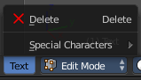
The Text menu contains the tools to work with text in edit mode.

Note that you have to use the Object mode box to escape the Edit mode with a text object. The hotkey to change the mode will be counted as text input for the text object.

Delete
Delete deletes the selected text.

To select parts of the text, move the cursor with the arrow buttons to the needed location, then hold down Shift, and select the letters by pressing the arrow buttons left or right. And then you can delete this selected text part.

Selecting text parts with the arrows brings up the Last Operator for Move Select.

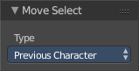
Last Operator Move Select

Type
Type is a drop-down box where you can change the selection method.

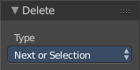
Last Operator Delete

Type
Type is a drop-down box where you can change the delete method.

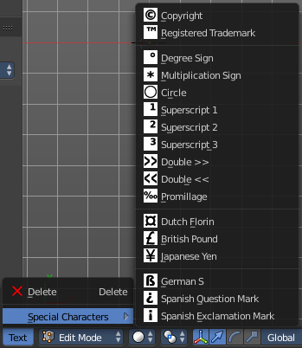
Special Characters
Special characters is a menu that contains some special text characters, like copyright, which you can insert into the text.

Edit Mode - Armature Object - Armature Menu

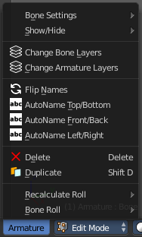
The armature menu provides you the tools to work with armatures and its bones in edit mode.

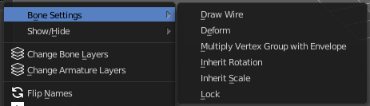
Bone Settings
Bone Settings is a menu with menu items to toggle special checkboxes in the Properties editor. But here you can do it for a selection too, and not just one object.

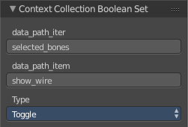
Last Operator Collection Boolean Set
Each of the menu items uses the same Last Operator. With different strings for the booleans.

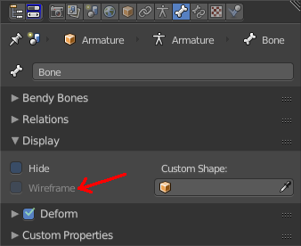
Draw Wire
Turns on or off the Wireframe checkbox, and so its functionality, in the Bones tab in the Display Panel Properties editor.
This checkbox requires to have a custom bone shape. It will not work at a normal bone shape. When you have a custom bone shape defined, then this custom bone object gets always displayed as Wireframe, regardless of viewport draw mode.

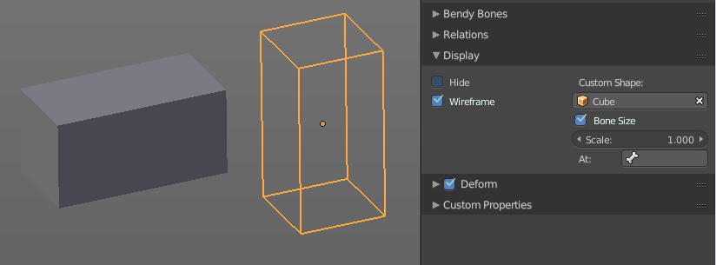

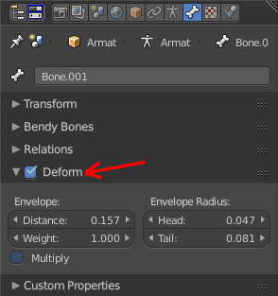
Deform
Turns on or off the Deform panel, and so its functionality, in the Bones tab in the Properties editor.
With Deform enabled the chosen bone deforms the connected mesh. The Deform panel also contains some Envelope settings.
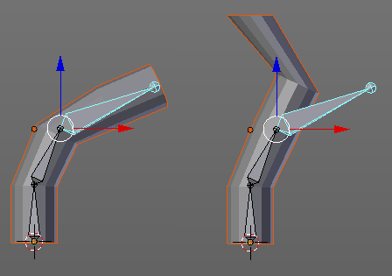

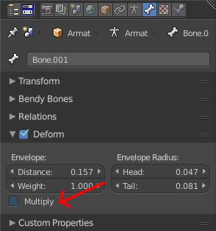
Multiply Vertex Group with Envelope
Turns on or off the Multiply checkbox in the Deform panel, and so its functionality, in the Bones tab in the Properties editor.
Multiply the effects of vertex group weights with envelope influence.

Inherit Rotation
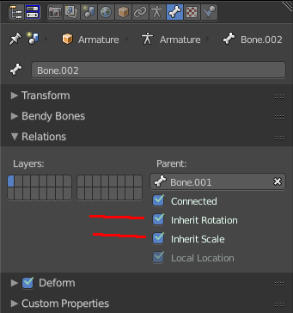
Turns on or off the Inherit Rotation checkbox in the Relations panel, and so its functionality, in the Bones tab in the Properties editor.
The bone inherits rotation from the parent bone.

Inherit Scale
Turns on or off the Inherit Scale checkbox in the Relations panel, and so its functionality, in the Bones tab in the Properties editor.
The bone inherits scale from the parent bone.

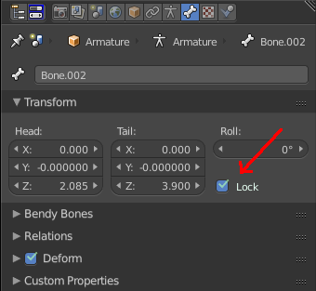
Lock
Turns on or off the Lock checkbox in the Transform panel, and so its functionality, in the Bones tab in the Properties editor.
Locked bones cannot be edited in edit mode anymore. They are locked.

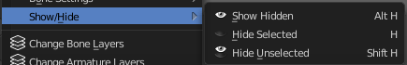
Show/Hide
Show/Hide is a menu. Here you can show or hide objects in the viewport. See chapter All Modes, all Object types - Show / Hide

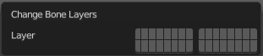
Change Bone Layers
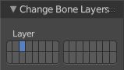
This menu item opens a popup where you can put single selected bone(s) onto another layer.

Last Operator Change Bone Layers

Layer
Here you can again put the selected bones onto another layer.

Change Armature Layers
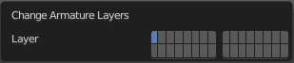
This menu item opens a popup where you can put the whole armature onto another layer.

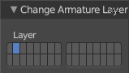
Last Operator Change Armature Layers

Layer
Here you can again put the armature onto another layer.

Flip Names
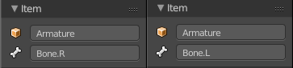
This tool requires to follow some name conventions. If there is a lower or upper case “L”, “R”, “left” or “right” with a separating dot in the bone name, then this tool renames the bones names to its counter part. Bone.L becomes Bone.R.
This tool is useful when you mirror parts of the armature, and don't want to rename all the bones one by one.

AutoName Top/Bottom
This tool automatically adds a suffix to all selected bones, based on their local position relative to the armature center.
Bones with a positive Z Coordinate will receive a .Top suffix. Bones with a negative Z coordinate will receive a .Bot suffix.

AutoName Front/Back
This tool automatically adds a suffix to all selected bones, based on their local position relative to the armature center.
Bones with a positive Y Coordinate will receive a .Fr suffix. Bones with a negative Y coordinate will receive a .Bk suffix.

AutoName Left/Right
This tool automatically adds a suffix to all selected bones, based on their local position relative to the armature center.
Bones with a positive X Coordinate will receive a .L suffix. Bones with a negative X coordinate will receive a .R suffix.

Delete Selected Bone(s)
Deletes the currently selected bones.

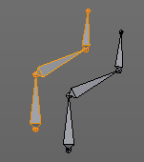
Duplicate
Duplicates selected bones. The duplicate is still part of the armature. The name number at the bones increases.
You are automatically in grab mode, and so you can easily move the object out of position. Which is sometimes wanted, since you can position the duplicate then. But sometimes this is unwanted. A right click after releasing the mouse lets the object snap back into its creation position.
When you drag the duplicate around you will see the position values in the header.

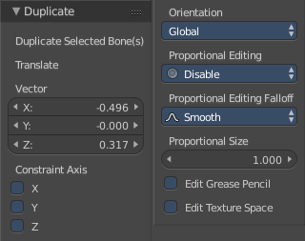
Last Operator Duplicate

Duplicate Selected Bone(s)
Just ignore this label.

Translate
Just ignore this label.

Constraint Axis
Here you can limit the position relative to the source object.

Orientation
Orientation is a drop-down box where you can choose the type of orientation for the mirroring action.

Proportional Editing
Proportional Editing is a drop-down box where you can choose to use proportional editing. When you choose one of the active methods then the neighbour geometry gets influenced by Shrink/Fatten too in a proportional way.

Proportional Editing Falloff
Proportional Editing Falloff is a drop-down box where you can choose a method for the falloff for the proportional editing.

Proportional Size
Proportional size is a edit box where you can adjust the strength of the Proportional falloff.

Edit Grease Pencil
Edit Grease Pencil edits the selected Grease Pencil strokes.

Edit Texture Space
With Confirm on Release checked the action gets performed when you release the mouse button.

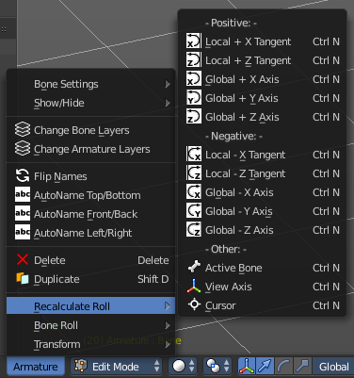
Recalculate Roll
Recalculate Roll is a menu where you can recalculate the bone roll in various ways.
The menu items are pretty self explaining. So we will not repeat the descriptions here.

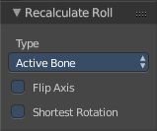
Last Operator Recalculate Roll

Type
Type is a drop-down box where you can choose the recalculation method again.

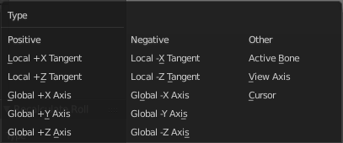
Flip Axis
Negates the alignment axis.

Shortest Rotation
Ignore the axis direction, and use the shortest rotation to align the bone(s)

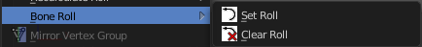
Bone Roll
Bone Roll is a menu where you can directly set the bone roll, or reset the bone roll to zero.

Set Roll
This operation is relative to the starting value, and starts always with zero. It does not display the Bone Roll value from the Transform panel. It adds or subtracts the amount of the operation to/from the Roll value then.
While operating you will see the current relative Roll value in the header.

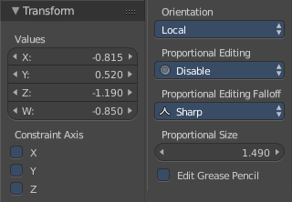
Last Operator Transform
The only interesting value is the X value right at the top. The other settings here are simply dysfunctional. You cannot turn on proportional editing, there is nothing to constraint, etc. . And so we will not go into detail here.
Unfortunately even the X value to display the amount of the roll is broken. It displays the amount in Radians, while the Bone roll is in degrees.

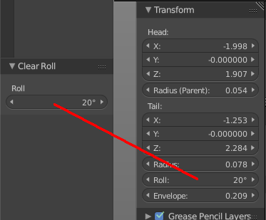
Clear Roll
Here you can set the bone roll value directly.

Last Operator Clear Roll

Roll
Here you can set the bone roll.

Edit Mode - Lattice Object - Lattice Menu
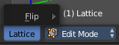
The Lattice menu provides you with tools to edit the Lattice object in edit mode.

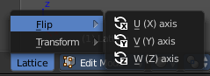
Flip
Flip is a menu where you can flip the lattice object along the world axis X, Y or Z

Pose Mode - Armature Object - Pose Menu

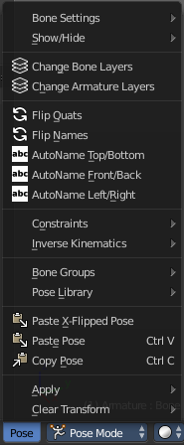
The Pose menu contains the tools to work with Armature objects in Pose mode. This means here you find all the tools that you need to pose and animate your armature.

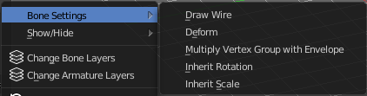
Bone Settings
Bone Settings is a menu with menu items to toggle special checkboxes in the Properties editor. But here you can do it for a selection too, and not just one object.

Last Operator Collection Boolean Set
Each of the menu items uses the same Last Operator. With different strings for the booleans.

Draw Wire
Turns on or off the Wireframe checkbox, and so its functionality, in the Bones tab in the Display Panel Properties editor.
This checkbox requires to have a custom bone shape. It will not work at a normal bone shape. When you have a custom bone shape defined, then this custom bone object gets always displayed as Wireframe, regardless of viewport draw mode.

Deform
Turns on or off the Deform panel, and so its functionality, in the Bones tab in the Properties editor.
With Deform enabled the chosen bone deforms the connected mesh. The Deform panel also contains some Envelope settings.

Multiply Vertex Group with Envelope
Turns on or off the Multiply checkbox in the Deform panel, and so its functionality, in the Bones tab in the Properties editor.
Multiply the effects of vertex group weights with envelope influence.

Inherit Rotation
Turns on or off the Inherit Rotation checkbox in the Relations panel, and so its functionality, in the Bones tab in the Properties editor.
The bone inherits rotation from the parent bone.

Inherit Scale
Turns on or off the Inherit Scale checkbox in the Relations panel, and so its functionality, in the Bones tab in the Properties editor.
The bone inherits scale from the parent bone.

Show/Hide
Show/Hide is a menu. Here you can show or hide objects in the viewport. See chapter All Modes, all Object types - Show / Hide

Change Bone Layers
This menu item opens a popup where you can put single selected bone(s) onto another layer.

Last Operator Change Bone Layers

Layer
Here you can again put the selected bones onto another layer.

Change Armature Layers
This menu item opens a popup where you can put the whole armature onto another layer.

Last Operator Change Armature Layers

Layer
Here you can again put the armature onto another layer.

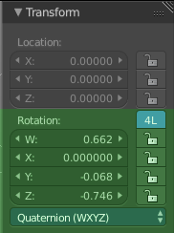
Flip Quats
This feature flips the quaternion rotation values of the currently selected bone(s). Positive values becomes negative, and negative values becomes positive.

Flip Names
This tool requires to follow some name conventions. If there is a lower or upper case “L”, “R”, “left” or “right” with a separating dot in the bone name, then this tool renames the bones names to its counter part. Bone.L becomes Bone.R.
This tool is useful when you mirror parts of the armature, and don't want to rename all the bones one by one.

AutoName Top/Bottom
This tool automatically adds a suffix to all selected bones, based on their local position relative to the armature center.
Bones with a positive Z Coordinate will receive a .Top suffix. Bones with a negative Z coordinate will receive a .Bot suffix.

AutoName Front/Back
This tool automatically adds a suffix to all selected bones, based on their local position relative to the armature center.
Bones with a positive Y Coordinate will receive a .Fr suffix. Bones with a negative Y coordinate will receive a .Bk suffix.

AutoName Left/Right
This tool automatically adds a suffix to all selected bones, based on their local position relative to the armature center.
Bones with a positive X Coordinate will receive a .L suffix. Bones with a negative X coordinate will receive a .R suffix.

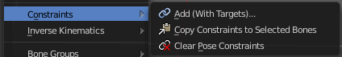
Constraints
Constraints is a menu that contains some tools around constraints.

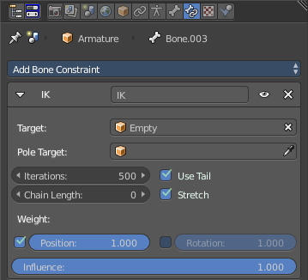
Add (With Targets)
Add (With Targets) calls the Constraints menu where you can choose the constraint that you want to add. When you add an IK constraints with just the bone selected, then it adds an empty as a handler too, and fills it in as a target.
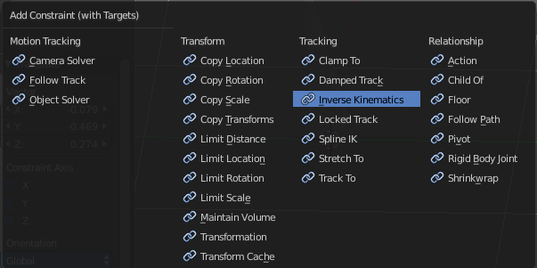
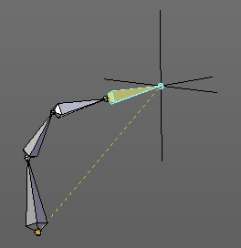

You can define a own target object too. The armature needs to be in pose mode. Let's create a cube or another primitive. Select it. Now hold down Shift, and click at the bone where you want to add the constraint too. Then choose Add (with Targets), and choose your constraint method. The cube will now be chosen as the target object.

Copy Constraints to selected Bones
Copies the constraints with all its settings to the selected bone.
Usage:
Select the bone where you want to copy the constraints to. Hold down shift, then select the bone that contains the constraints. Then perform the tool. The constraints will be copied.

Clear Pose Constraints
Removes all bone constraints modifiers from the bone.

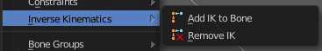
Inverse Kinematics
Inverse Kinematics is a menu with two isolated items from the whole bone constraints menu. The Inverse Kinematics. You could also add an Inverse Kinematics bone constraint by the Constraints / Add (With Targets) menu item from above. It is in the list. But this menu allows quick access without big search.

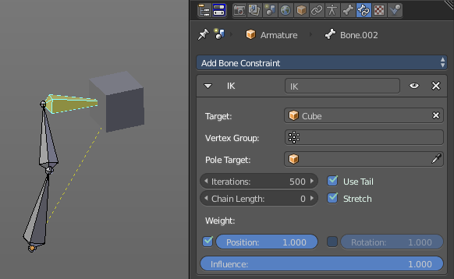
Add IK to Bone
Add IK to bone adds an IK bone constraint to the selected bone. When you add an IK constraints with just the bone selected, then it adds an empty as a handler too, and fills it in as a target.

You can define a own target object too. The armature needs to be in pose mode. Let's create a cube or another primitive. Select it. Now hold down Shift, and click at the bone where you want to add the constraint too. Then choose Add (with Targets), and choose your constraint method. The cube will now be chosen as the target object.

Last Operator Add IK to Bone

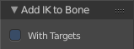
With Targets
Here you can define if you want to add the IK constraints with or without a target.

Remove IK
Removes all IK bone constraint(s) at the selected bone(s).

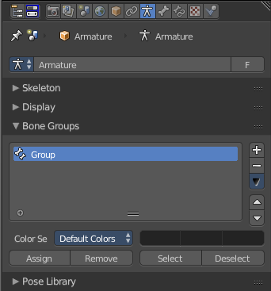
Bone Groups
Bone Groups is a menu to handle bone group functionality from within a menu in the 3D view. The bone groups themselves can be found in the Properties editor.

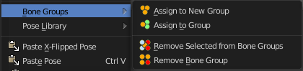

Assign to New Group
Assigns the selected bone(s) to a new group.

Assign to Group
Assigns the selected bone(s) to a existing group.

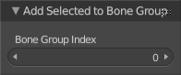
Last operator Add Selected to Bone Group
This last operator belongs to both tools. Assign to New Group, and Assign to Group.

Bone Group Index
Here you can adjust the Bone Group Index. An Index of 0 creates a new bone group. Higher values tries to assign the bone to existing bone groups instead.

Remove selected from Bone Groups
Removes the selected bone(s) from the assigned bone groups.

Remove Bone Group
Removes the currently active bone group.

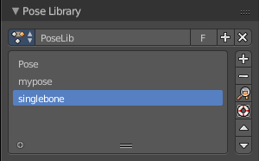
Pose Library
The content of this menu belongs to the Pose library. Which can be found in the Properties editor.
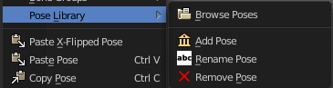

Browse Poses
With this feature you can browse through the available poses in the 3D view. While operation you will see informations in the header. It shows you what the current pose is, and how to navigate to the next or previous pose.
Note that you need to have the bones selected for which you want to display the poses. When in doubt, select all bones.

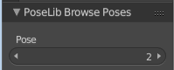
Last Operator Pose lib Browse Poses

Pose
Here you can scroll through the poses

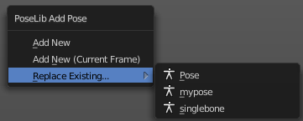
Add Pose
Here you can add a new pose for your armature to the pose library.
Note that you need to have the bones selected for which you want to add the pose. It just records the pose for the selected bones.
Calling the tool opens a popup where you can choose how you want to add the current pose.

Add New
Adds a new pose.

Add New (Current Frame)
Adds a new pose at the current frame. It does NOT record a keyframe.

Replace Existing
Here you can replace an existing pose.

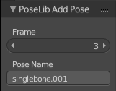
Last Operator Pose Lib Add Pose

Frame
The frame at which this pose should be created

Pose Name
Here you can rename the pose while creation.

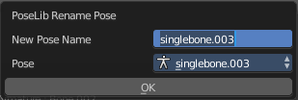
Rename Pose
Here you can rename a pose. It opens a popup menu where you can choose the pose to rename, and where you can rename it. One pose at a time.

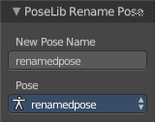
Last Operator Pose Lib Rename Pose

New Pose Name
Here you can enter the new pose name.

Pose
Here you can choose the pose that you want to rename.

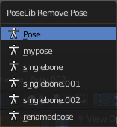
Remove Pose
Removes the currently active pose. The tool opens a popup where you can choose the pose to remove.

Last Operator Pose Lib Remove Pose

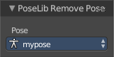
Pose
Here you can again choose which pose to remove.

Paste X-Flipped Pose
Pastes a formerly copied pose, and flips it around the X axis of the object. Local.

Paste Pose
Pastes a formerly copied pose.

Last Operator Paste Pose
This Last Operator belongs to both paste actions. Paste Pose and Paste X-Flipped Pose

Flipped on X-Axis
Flips the pasted pose around the X axis of the object.

On Selected Only
Pastes just to the currently selected bones. Not to the whole armature.

Copy Pose
Copies the current pose.

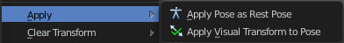
Apply
Apply is a menu with some Apply functionality.

Apply Pose as Rest Pose
You need a rest pose where you can reset the pose back to. With this tool you can set the current pose to be the new Rest pose.

Apply Visual Transform to Pose
Apply final constrained position of posed bones to their transform.

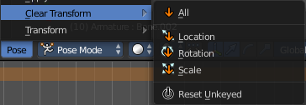
Clear Transform
Clear transform is a menu with some Clear functionality. You need to have the bones selected where you want to perform the operation. Unselected bones will not be calculated.

All
Resets location, rotation and scale back to the Rest pose.

Location
Resets location back to the Rest pose.

Rotation
Resets rotation back to the Rest pose.

Scale
Resets scale back to the Rest pose.

Reset Unkeyed
Resets the pose for the selected bones back to the state of the latest keyframe.

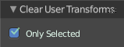
Last Operator Clear User Transforms

Only Selected
Clear User transform for selected armature part, or for the whole armature.

Sculpt Mode - Sculpt Menu

The Sculpt menu contains just one menu item at the moment. Subdivide.

Subdivide
Subdivide is a menu where you can quickly set the subdivision level of the selection.
What it does is to add a SDS modifier in the Properties Editor if required. And set the SDS level to the needed value.
Crtrl 0 sets SDS to level 0. Ctrl 1 sets SDS level to 1 , and so on.
SDS happens at Object mode level. Even when you apply it in the Sculpt Mode! And it happens at the whole object.

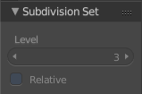
Last Operator Subdivision Set
The last operator Subdivision Set is greyed out in Sculpt mode.

Sculpt Mode - Brush Menu

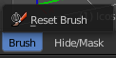
This menu contains brush related tools.

Reset Brush
Resets the current brush size to default size.

Sculpt Mode - Hide/Mask Menu
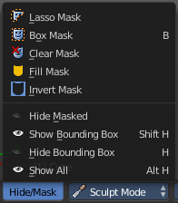
This menu contains some masking functionality.

Masking is a way to control which areas of the mesh are influenced by sculpting. To edit a mask manually, select the Mask Brush from the Brush panel.

Masked parts turns black.
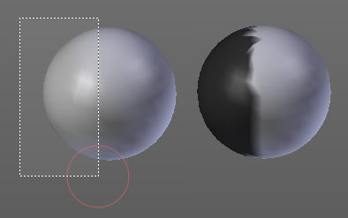
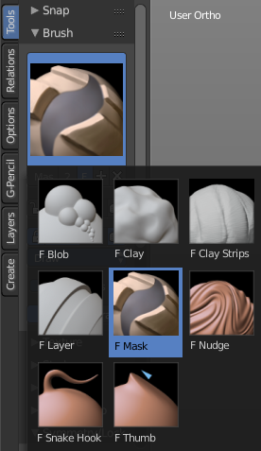

Lasso Mask
Select part of the mesh with a lasso tool.
Hotkey only tool, since the menu item is a bad starting point.

Box Mask
Select part of the mesh with a Rectangle tool.

Clear Mask
Clears the mask.

Fill Mask
Fills the mask with a given value, or inverts its values.

Invert Mask
Inverts the mask.

Hide Masked
Hides the masked mesh part.

Show Bounding Box
Lets you rectangle select a screen area to make hidden masked parts visible again.

Hide Bounding Box
Lets you rectangle select a screen area to hide mesh parts.

Show All
Makes all invisible mesh parts visible again.

Vertex paint Mode - Paint Menu

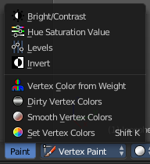
The Paint menu contains tools for vertex painting in Vertex paint mode.

Bright / Contrast
This tool allows you to adjust the brightness and the contrast of the vertex painting. You adjust the settings in the last operator.

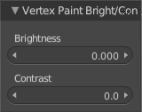
Last Operator Vertex Paint Bright/Contrast

Brightness
Adjust the brightness of the vertex colors.

Contrast
Adjust the contrast of the vertex colors.

Hue Saturation Value
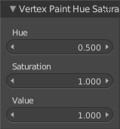
This tool allows you to adjust the hue, saturation and value values of the vertex painting. You adjust the settings in the last operator.

Last Operator Vertex Paint Hue Saturation Value

Hue
Adjust the Hue of the vertex colors.

Saturation
Adjust the Saturation of the vertex colors.

Value
Adjust the Value of the vertex colors.

Levels
This tool allows you to level the values of the vertex painting. You adjust the settings in the last operator.

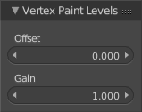
Last Operator Vertex Paint Levels

Offset
Adjust the Offset of the vertex colors.

Gain
Adjust the Gain of the vertex colors.

Invert
Inverts the vertex colors.

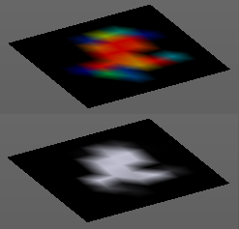
Vertex Color from Weight
This tool requires to have Weight Painting at the mesh. It converts the weight paint colors into greyscale vertex colors.

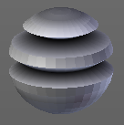
Dirty Vertex Colors
Dirty vertex colors is a special tool for ageing meshes. Let's for example imagine we have a relief. Edges that are outstanding are often touched, and tends to become brighter. While areas in the inner side of a relief are not so often touched. And here the relief collects dirt too. So this areas becomes darker.
And that's what the tool simulates. It makes the outer edges brighter, and the inner edges darker. This calculation is somehow similar to Ambient Occlusion. Ambient Occlusion makes corners darker. The dirty tool makes edges brighter too. And it calculates with the vertices. Not Texel positions like AO.
You need to convert this result to a texture to use it in your texturing, as a mask for example. This conversion can be done by baking.
The tessellation of the mesh should not be too high for this operation. Since it calculates the angles of the mesh edges.

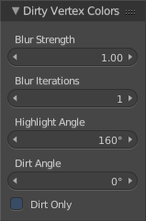
Last Operator Dirty Vertex Colors

Blur strength
How strong the result should be blurred

Blur Iterations
The number of iterations for the blur.

Highlight Angle
The angle for the bright areas. Angles higher as this value will not be recognized as a edge to highlight.

Dirt Angle
The angle for the dark areas. Angles lower as this value will not be recognized as a corner to darken.

Dirt only
Ignore the highlight areas, just calculate the dirt angles.

Smooth Vertex Colors
Smooths out the vertex colors.

Set Vertex Colors
Flood fills the vertex colors with the current vertex color value.

Weight Paint Mode - Select Menu

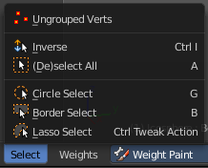
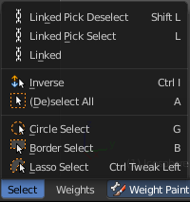
The Select menu in Weight Paint mode provides you with some selection tools for masking. This menu is just visible when you have either Face selection masking or vertex selection masking activated. The content differs between those two modes. Ungrouped Verts is just visible with Vertex Selection masking. The three "Linked" menu items just with Face Selection masking.

Linked
Just active with Face selection masking. Select linked faces.

Linked Pick Select
Just active with Face selection masking. Hotkey Only Functionality! This entry exists so that you know the tool is there and that you can edit the hotkey.
Linked Pick Select selects the linked faces under the cursor.

Linked Pick Deselect
Just active with Face selection masking. Hotkey Only Functionality! This entry exists so that you know the tool is there and that you can edit the hotkey.
Linked Pick Select deselects the linked faces under the cursor.

Ungrouped Verts
Just active with Vertex selection masking. Selects ungrouped Vertices.

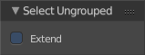
Last Operator Select Ungrouped

Extend
Extends the selection.

Inverse
Inverts the current selection.

(De)Select All
Toggles between select all and deselect all.

Last Operator (De)Select All

Action
Action is a drop-down box where you can choose between different methods.

Invert
Inverts the selection.

Deselect
Deselects all.

Select
Selects all.

Toggle
Toggles between select all and deselect all.

Circle Select
Circle select enters the Circle Select mode. This is a special select mode where you can select elements by moving with the mouse over it. It adds to selection by default.
To subtract from selection hold down Shift key. To exit the Circle select click with the right mouse button.
The pencil radius of the circle select tool can be adjusted with the scroll wheel.

Note
You cannot navigate while you are in Circle Select mode. You have to leave the Circle Select mode, do the navigation, then re enter the Circle Select mode.

Border Select
Border select enters the Border Select mode. This is a special select mode where you can select elements by dragging a rectangle. And what's inside of the rectangle gets selected then. It adds to selection by default.
To subtract from selection hold down Shift key.
The selection gets applied when you release the mouse. You leave the mode automatically when you release the mouse.

Lasso Select
Lasso select enters the Lasso Select mode. This is a special select mode where you can select elements by dragging a form around what you want to select. And what's inside of the rectangle gets selected then. It adds to selection by default.
To subtract from selection hold down Shift key.
The selection gets applied when you release the mouse. You leave the mode automatically when you release the mouse.

Note
You can of course also start with clicking at the menu item. But this tool is by design a hotkey only tool. Hold down Ctrl , and select with left mouse button.

Weight Paint Mode - Weights Menu
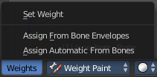
The weights menu contains some tools around Weight Painting.

Set Weight
This tool is just active when you have either Face selection masking or vertex selection masking activated.

The tool fills the selection with the current active Weight color that you have adjusted in the Brush panel in the Tools tab in the Tool shelf.

Assign from Bone Envelopes
Weights the vertices from the connected bone envelopes. And takes the distance to the bone envelope into account.

Assign Automatic from Bones
Weights the vertices connected with the bone. And takes the distance to the bone into account.

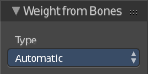
Last Operator Weight from Bones
This last operator is the same for both tools. Assign Automatic from Bones, and Assign from Bone Envelopes.

Type
Here you can choose if you want to Assign from Bone Envelopes, or from Bones.

Texture Paint Mode - Select Menu

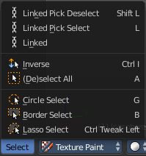
The Select menu in Weight Paint mode provides you with some selection tools for masking. This menu is just visible when you have either Face selection masking or vertex selection masking activated.

Linked
Select linked faces.

Linked Pick Select
Hotkey Only Functionality! This entry exists so that you know the tool is there and that you can edit the hotkey.
Linked Pick Select selects the linked faces under the cursor.

Linked Pick Deselect
Hotkey Only Functionality! This entry exists so that you know the tool is there and that you can edit the hotkey.
Linked Pick Select deselects the linked faces under the cursor.

Inverse
Inverts the current selection.

(De)Select All
Toggles between select all and deselect all.

Last Operator (De)Select All

Action
Action is a drop-down box where you can choose between different methods.

Invert
Inverts the selection.

Deselect
Deselects all.

Select
Selects all.

Toggle
Toggles between select all and deselect all.

Circle Select
Circle select enters the Circle Select mode. This is a special select mode where you can select elements by moving with the mouse over it. It adds to selection by default.
To subtract from selection hold down Shift key. To exit the Circle select click with the right mouse button.
The pencil radius of the circle select tool can be adjusted with the scroll wheel.

Note
You cannot navigate while you are in Circle Select mode. You have to leave the Circle Select mode, do the navigation, then re enter the Circle Select mode.

Border Select
Border select enters the Border Select mode. This is a special select mode where you can select elements by dragging a rectangle. And what's inside of the rectangle gets selected then. It adds to selection by default.
To subtract from selection hold down Shift key.
The selection gets applied when you release the mouse. You leave the mode automatically when you release the mouse.

Lasso Select
Lasso select enters the Lasso Select mode. This is a special select mode where you can select elements by dragging a form around what you want to select. And what's inside of the rectangle gets selected then. It adds to selection by default.
To subtract from selection hold down Shift key.
The selection gets applied when you release the mouse. You leave the mode automatically when you release the mouse.
Note
You can of course also start with clicking at the menu item. But this tool is by design a hotkey only tool. Hold down Ctrl , and select with left mouse button.

Particle Mode - Select Menu

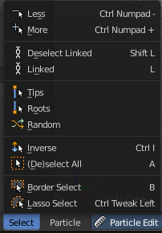
The Select menu in Particle mode provides you with some selection tools to edit the particles.

When you are in Emitter mode then most of the menu items are greyed out. This menu items are for Hair particles.

Less
Select less.

More
Select more.

Linked
Select linked geometry.

Deselect Linked
Deselect linked geometry.

Select Tips
Selects the end vertices of hair particles.

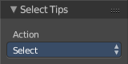
Last Operator Select Tips

Action
A dropdown box where you can choose what you want to do.

Select Roots
Selects the start vertices of hair particles.

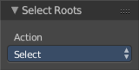
Last Operator Select Roots

Action
A dropdown box where you can choose what you want to do.

Random
Selects random objects.

Last Operator Select Random

Percent
The Percentage of objects that should be selected randomly.

Random Seed
The Seed for the random number generator.

Action
Action is a drop-down box where you can choose if you want to select or to deselect random.

Inverse
Inverts the current selection.

(De)Select All
Toggles between select all and deselect all.

Last Operator (De)Select All

Action
Action is a drop-down box where you can choose between different methods.

Invert
Inverts the selection.

Deselect
Deselects all.

Select
Selects all.

Toggle
Toggles between select all and deselect all.

Border Select
Border select enters the Border Select mode. This is a special select mode where you can select elements by dragging a rectangle. And what's inside of the rectangle gets selected then. It adds to selection by default.
To subtract from selection hold down Shift key.
The selection gets applied when you release the mouse. You leave the mode automatically when you release the mouse.

Lasso Select
Lasso select enters the Lasso Select mode. This is a special select mode where you can select elements by dragging a form around what you want to select. And what's inside of the rectangle gets selected then. It adds to selection by default.
To subtract from selection hold down Shift key.
The selection gets applied when you release the mouse. You leave the mode automatically when you release the mouse.

Note
You can of course also start with clicking at the menu item. But this tool is by design a hotkey only tool. Hold down Ctrl , and select with left mouse button.

Particle Mode - Particle Menu

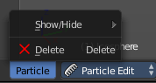
The Particle menu contains some tools to modify the particles.

Show/Hide
Show/Hide is a menu. Here you can show or hide objects in the viewport. See chapter All Modes, all Object types - Show / Hide

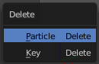
Delete
Brings up a popup where you can choose to delete either the selected particle(s) or the selected key(s).

Last Operator Delete

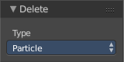
Type
Here you can again choose what type to delete. Particle or Key.

Grease Pencil - Edit Strokes Mode

The Edit strokes mode allows you to edit your grease pencil strokes. The Select menu contains the usual select methods. The GPencil menu contains some further functionality.

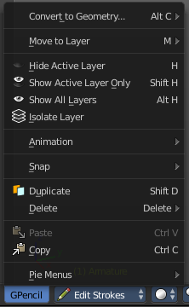
Gpencil Menu

Convert to Geometry
Convert to Geometry is a sub menu with thee menu items.
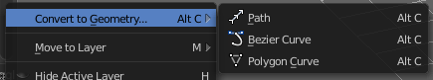

Path
Convert selected Grease pencil stroke into a Path.

Bezier Curve
Convert selected Grease pencil stroke into a Bezier Curve.

Polygon Curve
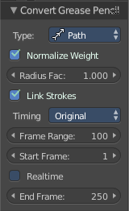
Convert selected Grease pencil stroke into a Polygon Curve.

Last Operator Convert Grease Pencil

Type
Here you can again choose the conversion method again.

Normalize Weight
Normalize weight, set from stroke width

Radius Multiplier
Multiplier for the points radii, set from stroke width

Link Strokes
Link strokes with zero radius sections of curves.

Timing
For animation - the timing method

Frame Range
For animation - the frame range

Start Frame
For animation - the start frame

Realtime
For animation - Realtime update or not

End Frame
For animation - the end frame

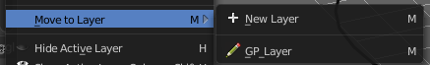
Move to Layer
Grease pencil strokes gets created at layers. Here you can move the strokes to a new layer

New Layer
Creates a new layer, and moves the selection to this layer.

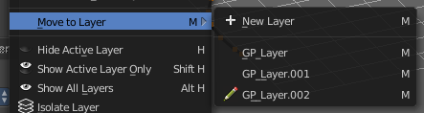
GP Layer
Choose an existing layer and move the selection to this layer.

Last Operator Move Strokes to Layer
Here you can again decide if you want to create a new layer, or if you want to move the selection to an existing layer.

Hide active layer
Hides the active layer.

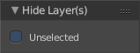
Last operator Hide Layer(s)

Unselected
Hides the unselected layers. See next point.

Show Active Layer only
Should be called Hide unselected! Show active layers, and hide all others.

Last operator Hide Layer(s)

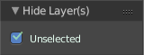
Unselected
Hides the unselected layers.

Show all Layers
Makes all hidden layers visible.

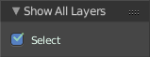
Last Operator Show All Layers

Select
Selects all geometry in the layer.

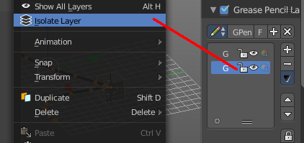
Isolate Layer
Locks the active layer. This corresponds with the lock symbol in the Grease Pencil Layers panel.

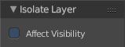
Last Operator Isolate Layer

Affect Visibility
Make the layer invisible too.

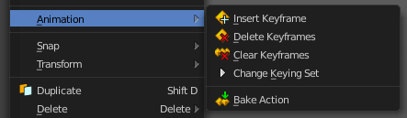
Animation
Animation is a sub menu around animation functionality. You need to have an object in the scene.

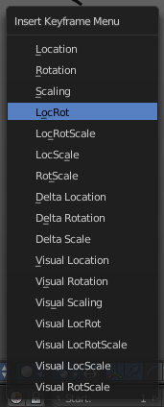

Insert Keyframe
Opens a menu where you can insert a keyframe with a defined keying set.

Delete Keyframes
Deletes keyframes at the current frame.

Clear Keyframes
Deletes all keyframes.

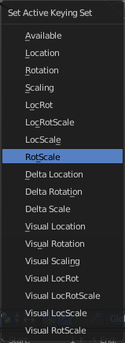
Change Keying Set
Opens a menu where you can change the keying set.

Bake Action
Bake the keyframes into an action.
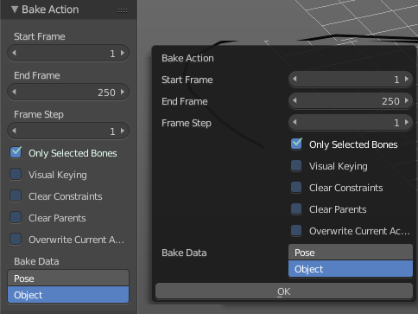
This tool calls a dialog with the bake settings. They are identical with the last operator.

Start Frame
Defines the start frame.

End Frame
Defines the end frame.

Frame Step
Defines the number of keyframes per step

Only Selected
Only key selected bones.

Visual Keying
Keyframe from the final transformations.

Clear Constraints
Remove all constraints and do visual keying.

Clear Parents
Bake animation onto teh object, then clear parents. This is for objects only.

Overwrite current Action
Bake animation into current action.

Bake Data
You can either bake to pose, or bake to object.

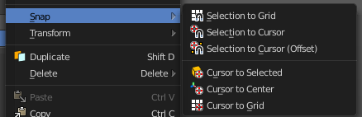
Snap
Snap is a sub menu with snapping functionality.

Selection to Grid
Selection to Grid snaps the selected element(s) to the closest Grid point.

Selection to Cursor
Selection to Grid snaps the selected element(s) to the 3D cursor. ALL selected elements will end at cursor position. For example all selected vertices.

Selection to Cursor ( Offset )
Selection to Grid snaps the selected element(s) to the 3D cursor. The centre of the selected elements will snap to the 3D cursor. A group of vertices for example will remain its shape.

Cursor to Selected
Cursor to Selected snaps the 3D cursor to the selected element.

Cursor to Centre
Cursor to Centre snaps the 3D cursor to the centre of the world.

Cursor to Grid
Cursor to Grid snaps the 3D cursor to the closest Grid point.

Duplicate
Duplicates the current selection. The copy sticks to the mouse until you release it. A Right click while moving will reset the position of the duplicate. The duplicated part will be part of the same object.
When you drag the duplicate around you will see the position values in the

Delete
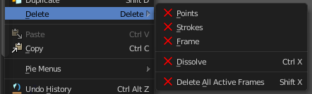
Delete is a sub menu where you can define what exactly you want to delete.

Points
Delete the vertices of the selection. The strokes gets split at this point.

Strokes
Delete the whole stroke(s).

Frames
Delete the grease pencil frames.

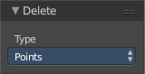
Last Operator Delete

Type
Type is a dropdown box where you can choose the delete method again.´

Dissolve
Delete selected points without splitting strokes.

Delete all active frames
Delete all active frames of all editable grease pencil layers.

Copy
Copies the selected selection(s).

Paste
Pastes copied selection(s).

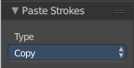
Last Operator Paste Strokes

Select
Select pasted object(s).

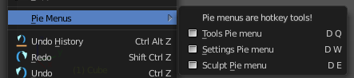
Pie menus
Pie menus is a sub menu that contains operators to call pie menus. This pie menus contains the tools from the tool shelf, and provides an easier access, since the menu appears directly under the mouse.

This pie menus are hotkey tools! They are meant to be used with hotkeys in the 3D viewport. The menu entries are fully functional. They call the pie menus. But are meant as a visual hint.

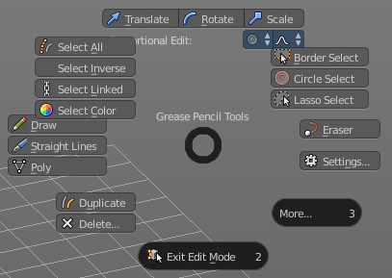
Tools Pie menu

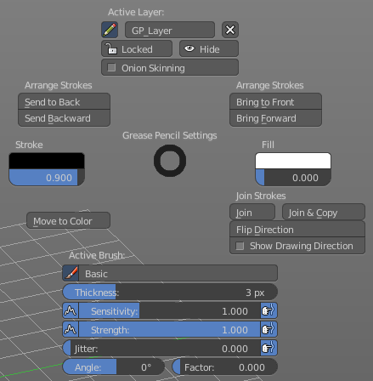
Settings Pie menu

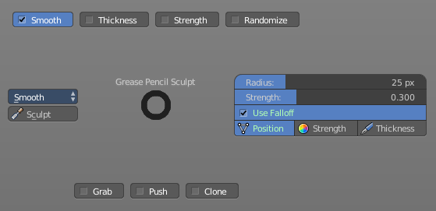
Sculpt Pie menu

Header Tool - Mode Drop-down Box

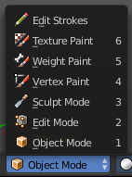
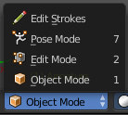
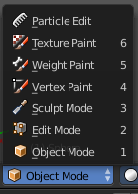
The Mode drop-down box allows you to switch between the different modes.

Modes are object states that allows you to edit and manipulate objects at different levels with different tool sets and goals. The sculpt mode for example allows you to sculpt a mesh object. Edit Mode allows to manipulate the mesh of the object, and so on.

The available modes can differ from object to object. A armature for example has an additional pose mode. And when you work with the grease pencil, then the Edit Strokes mode becomes available.

Object Mode
This mode allows to manipulate objects at Object level. Like move it around, rotate it, etc. This mode is available for all object types.

Edit Mode
The edit mode allows to edit the object. With a mesh object this means that you are able to modify and to change the geometry. With an armature you build your skeleton. And with a text object you can type in text, and choose the font etc.
Not all objects has an edit mode.

Sculpt Mode
Sculpt mode is a mesh object only mode. In this mode you can sculpt the mesh.

Vertex Paint
Vertex Paint is a mesh object only mode. In this mode you can paint vertices with colors.

Weight Paint
Weight Paint is a mesh object only mode. In this mode you can adjust weight painting for an armature for example. But Weight Painted mesh objects can also be used in conjunction with particles.

Texture Paint
Weight Paint is a mesh object only mode. In this mode you can paint at the texture of a mesh directly. This mode requires to have a working UV mapping and a texture at the mesh object.

Edit Strokes
Edit Strokes is a Grease Pencil only mode. It allows to manipulate the curves at a mesh level.

Particle Edit
Particle edit is a Particle System mode only. When you apply a particle system to a mesh object then this mode becomes available. It allows you to manipulate the particle system at a mesh level. You can comb hair particles for example.

Header Tool - 3D Manipulator Widget
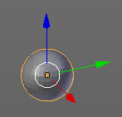
The 3D Manipulator widget tool allows you to enable and to disable a 3D Manipulator widget in the viewport. It is made of several sub elements.
This element exists in most modes. But in Sculpting mode for example the 3D Manipulator is not available.

3D Manipulator
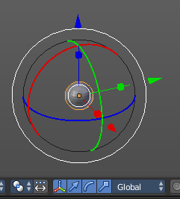
This button activates or deactivates the widget. Have a look at the shortcut here.

Transformation manipulator Translate, Rotate and Scale
Here you can activate or deactivate three different types of widgets. One for Translate, one for Rotate, one for Scale.
You can also activate more than one widget at a time. Hold down shift while clicking at one of the buttons adds to the selection.
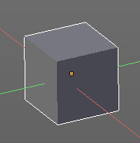
When you use the translate and scale widget, then you can transform in two directions by holding down shift. For example when you use translate widget and pull at the blue handler for upwards in Z direction, then you don't pull upwards, but sidewards in X and Y direction. The green and red line indicates the movement freedom.

When you use the Translate widget and hold down Ctrl, then you move the object with a snapping of one unit.

Last Operator Translate, Rotate and Resize
For the last Operator Translate, Rotate and Resize please have a look in the chapter Navigation Menu. They are identical.

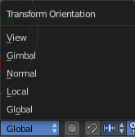
Transform Orientation
Transform Orientation is a drop-down box where you can choose between different orientation methods for the transform operation. The widget points into this direction then.

View
The transform orientation aligns to the current view.

Gimbal
Aligns each axis to the Euler rotation axis as used for input.

Normal
This is of interest for bones for example. Aligns the transformation axis to average normal of the selected elements. Bone Y axis for Pose mode.

Local
Uses the local orientation of the selected elements.

Global
Uses the global orientation for the selected elements.

Header Tool - Proportional Editing

Proportional editing is a way to transform selected elements with some kind of a falloff. So when you for example pull a vertice upwards in Edit mode, the neighbour vertices will also pull upwards, but not so strong. The neighbours gets influenced proportional.
Proportional Editing is not available in all modes.

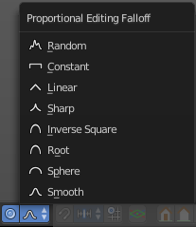
Proportional editing in Object mode is made of two elements. The on off switch. And a drop-down box where you can choose the falloff method.

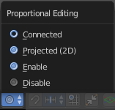
In Edit Mode with a mesh object you just have the on off switch. But here you can choose between three different falloff modes.
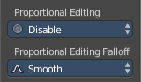
Both settings can be found in the Last Operator panel, when you for example move or scale an object or selection.

Changing the Proportional influence radius
You can change the influence radius for proportional editing with the mouse wheel or the Page up Page down arrows while keeping the mouse button pressed down for translate, rotate or scale. Or at the widget.

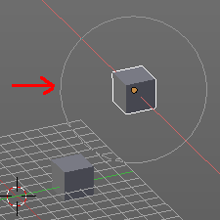
Usage:
Create for example two cubes. Now move one of it around. Enable proportional editing. Choose your favourite falloff method if you want.
When you click at the widget you will see a white circle around the Pivot point. That's the influence radius for the proportional editing.
Now increase the radius for falloff. So that the second cube is in the influence radius. You will see it moving at one point.
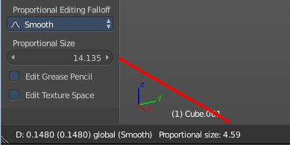
In the last operator Translate there is also a Proportional Size edit box that shows you the size of the radius. Here you can adjust the value too. But note that it will not update the visible influence radius in the 3D view. And when you change the radius in the viewport with the scroll wheel, then it will use the old value, and not the value that you have typed in here. So you better adjust the radius in the viewport. And use this edit box as a visual feedback.

Header Tool - Transform Snapping

Transform Snapping
This element is for snapping while transformation. Not to mix with the snapping tools in the Tools tab in the Tool Shelf. The Transform Snapping tool includes for example grid snapping.
Transform Snapping is not available in all modes.
The Transform Snapping tool is made of three elements.

Transform Snapping
Here you enable or disable snapping.

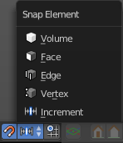
Snap Element
Snap Element is a drop-down box where you can choose between different snapping methods.

Volume
Snapping happens to the volume of another object.

Snapping
Snapping happens to the face of another object.

Edge
Snapping happens to the Edge of another object.

Vertex
Snapping happens to the Edge of another object.

Increment
Snapping happens relative to the ground grid.

Absolute Grid alignment while translating
With this feature on the selection snaps to the grid points. Without this feature it snaps increasing by unit size. When you have a grid snapping of 1, and an element at 0.56, then without absolute grid alignment it will snap at 1.56, 2.56 etc. With absolute grid snapping it will snap at 0, 1, 2 etc.

Header Tool - Viewport Shading

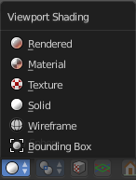
The Viewport shading drop-down box contains the different shading modes for the viewport. It exists in all modes.

Rendered
Displays the content in the viewport like you would have rendered it. This mode is dependant of what render engine you have currently active. And is available for Blender Render and Cycles.

Material
Displays the content in the viewport with all material settings and with OpenGL rendering.

Texture
Displays the content in the viewport textured. You need of course a working UV mapping and a texture at the mesh to see it.

Solid
Displays the content in the viewport with a solid white color.

Wireframe
Displays the content in the viewport as Wireframe.

Bounding Box
Displays the content in the viewport as Bounding box. The mesh content is not displayed.

Header Tool - Pivot Point

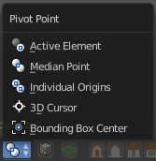
The Pivot Point is the point around which the object manipulation happens. Rotation, mirroring, and so on. Normally this happens around the pivot of the active object. In this menu you can set the pivot point to other locations. Like the position of the 3D cursor.

It exists in all modes.

Active Element
With this setting the manipulation happens relative to the center of the selected active elements. With more than one element is involved, then in Object mode this center gets calculated from the elements pivots. In edit mode the pivot is also the median point.

Median Point
With this setting the manipulation happens relative to the median point of the selected elements. This can be another point than calculating the center of the pivots. The median gets calculated from the geometry, not from the pivot point of the geometry.

Individual Origins
With this setting the manipulation happens relative to the origins of the selected elements. The origin is the little orange dot in every element.

3D Cursor
With this setting the manipulation happens relative to the 3D cursor.

Bounding Box Center
With this setting the manipulation happens relative to the Bounding Box Center.

Header Tool - Manipulate Center Points

This option is of interest when you have more than one object selected. With this option enabled a transformation will change the positions of the object’s origins, but will not affect the object itself.
For example, when you want to scale a group of selected cubes. Without the option enabled the cubes will scale also down when you scale the selection. With this option enabled, the cubes will keep their size. But they will scale closer together. The Pivot points gets scaled.

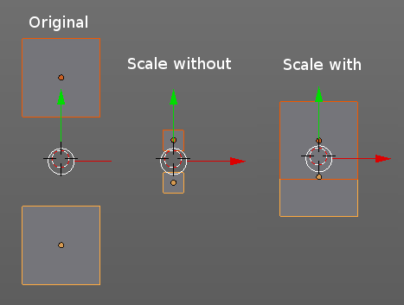

Header Tool - Mesh Object - Edit Mode - Mesh Select Mode

The mesh select mode in Edit Mode with a Mesh object allows you to switch between the three available selection modes Vertice select, Edge Select and Face Select.

You can have more than one mode active by shift clicking at the other mesh select modes.

Header Tool - Mesh Object - Edit Mode - Limit Selection to Visible

Limit selection to visible limits the view to what you can see from the front. By default the back geometry shines a bit through.
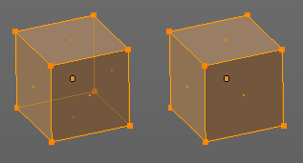

Header Tool - Mesh Object - Face selection masking for Painting

Painting at a Mesh object has two header tools that just belongs to the painting operations. One of it is Face selection masking for Painting. It is visible in Vertex Paint Weight Paint and Texture Paint.

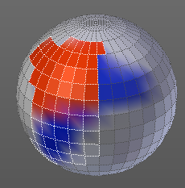
Face selection masking for Painting
When you activate this tool then you reveal a Select menu in the header. And you can select the mesh parts that you want to manipulate.
Note that you may first want to deselect all. By default everything is selected ...
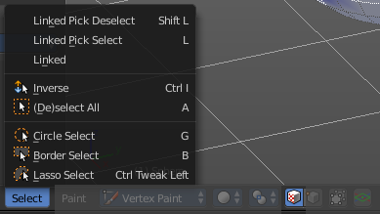

The select menu is explained in the chapter Vertex Painting - Select Menu.

Header Tool - Mesh Object - Vertex selection masking for Painting

Painting at a Mesh object has two header tools that just belongs to the painting operations. One of it is Face selection masking for Painting. It is visible in Vertex Paint and Weight Paint.

Vertex selection masking for Painting
When you activate this tool then you reveal a Select menu in the header. And you can select the mesh parts that you want to manipulate.
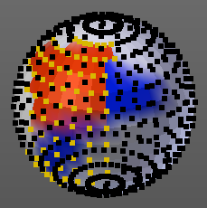
This tool is meant for Weight Painting. And so the mesh displays the vertices too.
Note that you may first want to deselect all. By default everything is selected ...
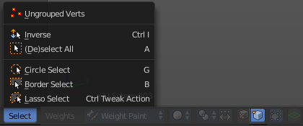

The select menu is explained in the chapter Vertex Painting - Select Menu.

Header Tool - Particle Edit - Select modes

The Select modes allows you to change the display and the editability of the particle vertices.

Path
No keypoints are visible. You can only select or deselect all keypoints at once.

Point
You see all keypoints. And all keypoints are editable

Tip
You can only see and edit the tip keypoints.

Header Tool - Reset 3D View

Reset 3D View is a navigation element. It resets the 3D view to a predefined setting.

It exists in all modes.

Reset 3D View is an add-on, and can be uninstalled when wanted. But note that the functionality is missing then.

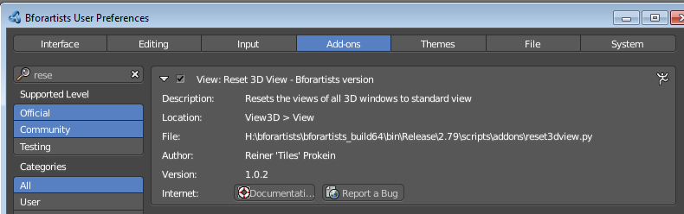

Header Tool - Align View Buttons
The Align View buttons contains some quick navigation elements to navigate in the viewport. You can switch between the different views, switch between orthographic and perspectivic view, switch to camera view and back to viewport view, and set the active camera.
It exists in all modes.
Align View Buttons is an add-on, and can be uninstalled when wanted. But note that the functionality is missing then.
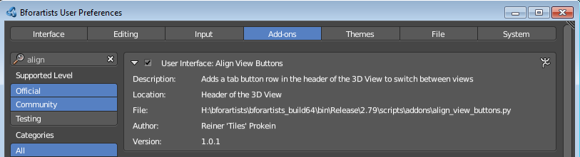

Top, Bottom, etc.
Switches to Top view, Bottom View, etc.

View Persp/Ortho
Toggles between perspectivic and orthographic view. Perspectivic view acts like a real camera with the perspectivic distortions. Orthographic view acts like a mathematical display of an object, without distortions.

Align View to active Camera
Switches to Camera view and back to Viewport Camera.

Set Active Camera
Sets the currently selected camera as the active camera. The active camera is the camera that gets used for rendering.
You need to have a camera object selected to activate the tool. Unlike the tool in the View menu, this tool here just works for camera objects.

